**i**

**Aligarh College of Engineering & Technology**

**Department Of Computer Science and Engineering**

**ACKNOWLEDGEMENT**

The satisfaction and euphoria that accompany the successful completion of any task would be incomplete without mentioning the names of people who made it possible, whose constant guidance and encouragement crowns all efforts with our success.

I extend my gratitude to **Mr. VINAY TANDON**, Head- Department of Master of Computer Application, Aligarh College Of Engineering and Technology Aligarh, Uttar Pradesh for providing me with excellent infrastructure and awesome environment that laid potentially strong foundation for my professional life .

I would like to express my profound thanks to **Mr. Sharad Saxena**, Assistant Professor who guided me throughout the project tenure, provided me each and every detail, references, and technical helps without which it was impossible to complete this project. I am also thankful to **Mr.Sharad Saxena**, Assistant Professor for their help and guidance throughout my project.

Finally, I also wish to thanks to GOD for supporting me during my whole project work.

**ii**

**ABSTRACT**

The **Pharmacy Management System** is a Java-based desktop application designed to simplify and automate pharmacy operations. It supports three primary user roles—**Admin**, **Pharmacist**, and **Customer**—each with distinct responsibilities.

The **Admin** role is responsible for managing user accounts, including adding, viewing, and updating user information, as well as overseeing user profiles. The **Pharmacist** manages the medicine inventory, processes sales, generates bills, and maintains the sales history. The **Customer** (or user) can browse and purchase medicines, and their transaction records are stored in the system for future reference.

The system uses **Java Swing** for the GUI and **MySQL** for data management, integrating external libraries such as **AbsoluteLayout** for layout control, **iText** for PDF generation, **JCalendar** for date selection, and **MySQL Connector/J** for database connectivity. This solution enhances efficiency, reduces manual errors, and offers a reliable, user-friendly interface for pharmacy management.

Tools & Technology Used:

* Language - Java SE
* Database - MySQL
* **GUI Framework -**  Java Swing
* **Libraries -** AbsoluteLayout, iText, JCalendar, MySQL Connector/J

iii

**Table of Contents**

* **Certificate i**
* **Acknowledgement ii**
* **Abstract iii**

**1. Introduction** 7

**2. System Specification**

2.1 Hardware Requirement 8

2.2 Software Requirement 8

**3. System Study And Analysis 9-10**

**4. Feasibility Study 11-12**

4.1 Technical Feasibility 11

4.2 Economic Feasibility 12

4.3 Behavioral Feasibility 12

**5. System Design 13-15** 5.1 Introduction 13

5.2 Logical Design 13

5.3 Physical Design 13

5.4 Design/Specification Activities 14

**6. Modules Design 15-17**

6.1 Input Design 15

6.1.1 Objectives 15

6.2 Output Design 16

6.3 Database Design 17

**7. Data Flow Diagrams 18-20**

7.1 Symbols Used in DFD 18

7.2 Zero Level DFD 19

7.3 First Level DFD 20

**8. Table Design**  21

**9. Implementation ,Testing & Maintenance 22**

**10. Coding** **23-70**

**11. Input Output Screen 71-74**

**12. Final Outptut 75**

**13. Future Scope 76**

**1. INTRODUCTION**

The Pharmacy Management System is a robust, Java-based desktop application developed to streamline and automate various operations within a pharmacy environment. Designed with efficiency and usability in mind, the system caters to three primary user roles: Admin, Pharmacist, and Customer, each with dedicated functionalities tailored to their responsibilities.

The Admin plays a supervisory role within the system, tasked with managing user accounts and maintaining user profiles. This includes adding new users, updating existing information, and monitoring user activities. Admins ensure that the system is securely managed and that only authorized personnel can access sensitive features.

Pharmacists are central to the daily operations of the pharmacy. They are responsible for managing the medicine inventory, processing customer sales, generating digital bills, and maintaining a comprehensive sales history. This role ensures accurate stock tracking, efficient customer service, and consistent record-keeping, reducing the risk of errors associated with manual processes.

Customers, on the other hand, can interact with the system to browse available medicines and make purchases. Their transaction records are securely stored, allowing for easy access to purchase history and billing details for future reference or inquiries.

Technologically, the system is built using Java Swing for a responsive and intuitive graphical user interface (GUI). MySQL serves as the database backend, offering reliable and structured data management. The system integrates several external libraries to enhance functionality: AbsoluteLayout for custom GUI layouts, iText for PDF bill generation, JCalendar for user-friendly date selection, and MySQL Connector/J for seamless database connectivity.

By automating key pharmacy operations, the Pharmacy Management System enhances overall efficiency, reduces the likelihood of human error, and offers a reliable, user-friendly platform for managing a modern pharmacy. This solution is especially beneficial for small to mid-sized pharmacies seeking a cost-effective way to digitize their workflows.

1. **SYSTEM SPECIFICATION**

## **Hardware Requirements**

CPU : PENTIUM IV

SPEED : 2.10 GHz

COPROCESSOR : BUILT IN

RAM : Minimum 4 GB

HARD DISK : 250 GB

KEYBOARD : 105 KEYS

MOUSE : LOGITECH MOUSE

DISPLAY : SGVA COLOR

## **2.2. Software Requirements**

* **Front-End Technology**: Java SE with Swing for GUI development
* **Back-End Database**: MySQL
* **Operating System**: Windows 10 or later.
* **External Libraries & Tools**:

1. **AbsoluteLayout**: For GUI layout management
2. **iText**: For PDF generation
3. **JCalendar**: For date selection components
4. **MySQL Connector/J**: For Java-MySQL database connectivity

**3. SYSTEM STUDY AND ANALYSIS**

System analysis is a crucial phase in software development that involves understanding current processes, identifying problems, and proposing improvements. It is a problem-solving activity that requires close collaboration between system users and developers. The system is examined as a whole, with attention to inputs, processes, and outputs. The goal is to analyze current operations, pinpoint inefficiencies, and suggest optimal solutions through detailed data collection methods like interviews and questionnaires.

The **existing system**—typically manual—is studied in depth to recognize pain points. Based on the insights, various solution proposals are developed. These are then compared with the current system to select the most effective option. This is an iterative process, where proposals are refined based on user feedback until an acceptable solution is finalized.

The **preliminary study** further helps determine system feasibility and guides the strategy for detailed system analysis. It includes technical, operational, and economic feasibility assessments to ensure the proposed solution is practical and sustainable.

### Application to Pharmacy Management System

In the case of the **Pharmacy Management System**, the analysis focused on understanding existing manual operations such as user management, medicine inventory tracking, sales processing, and billing. Communication with pharmacists and administrators highlighted key operational challenges like manual errors, inefficiencies, and lack of integration.

Based on this, a role-based, automated desktop application was proposed using **Java Swing** for the GUI and **MySQL** for data management. External libraries like iText, JCalendar, and MySQL Connector/J were selected to enhance functionality. The analysis confirmed that automating these processes would significantly improve accuracy, reduce workload, and streamline pharmacy operations.

This detailed system study laid the foundation for the design and development of the Pharmacy Management System, ensuring that it effectively addresses user needs and technical requirements.

**4. EXISTING SYSTEM**

In the existing system the company process are done only manually but in proposed system we have to computerize all the transaction using the software Management.

## **4.1. Problems With Existing System**

* Lack of security of data.
* More man power.
* Time consuming.
* Consumes large volume of pare work.
* Needs manual calculations.
* No direct role for the higher officials.
* Damage of machines due to lack of attention.

To avoid all these limitations and make the working more accurately the system needs to be computerized.

## **4.2. Proposed System**

The aim of proposed system is to develop a system of improved facilities. The proposed system can overcome all the limitations of the existing system. The system provides proper security and reduces the manual work.

## **4.2.1. Advantages of the Proposed System**

The system is very simple in design and to implement. The system requires very low system resources and the system will work in almost all configurations. It has got following features

* Security of data.
* Ensure data accuracy’s.
* Proper control of the higher officials.
* Reduce the damages of the machines.
* Minimize manual data entry.
* Minimum time needed for the various processing.
* Greater efficiency.
* Better service.
* User friendliness and interactive.
* Minimum time required.

# 5. FEASIBILITY STUDY

Feasibility study is made to see if the project on completion will serve the purpose of the organization for the amount of work, effort and the time that spend on it. Feasibility study lets the developer foresee the future of the project and the usefulness. A feasibility study of a system proposal is according to its workability, which is the impact on the organization, ability to meet their user needs and effective use of resources. Thus when a new application is proposed it normally goes through a feasibility study before it is approved for development.

The document provide the feasibility of the project that is being designed and lists various areas that were considered very carefully during the feasibility study of this project such as Technical, Economic and Operational feasibilities. The following are its features:

**5.1. TECHNICAL FEASIBILITY**

The system has been evaluated from a technical standpoint based on the preliminary design, which outlines the required inputs, outputs, processes, and procedures. This evaluation includes an assessment of the hardware and software environment, development tools, and the system's operational viability post-deployment.

Key technical considerations include:

* **Sufficiency of existing technology** to support the proposed system.
* **Scalability and extensibility** of the system for future enhancements.

The **Pharmacy Management System** is developed using **Java SE** with **Swing** for the graphical user interface and **MySQL** as the backend database. These technologies are widely used, well-supported, and compatible with standard hardware environments. The use of external libraries such as **AbsoluteLayout**, **iText**, **JCalendar**, and **MySQL Connector/J** ensures enhanced functionality and ease of development.

While technological obsolescence is a potential long-term concern, the chosen tools and frameworks are currently stable and well-documented, ensuring the system performs reliably within defined requirements. Additionally, the system's modular architecture allows for future upgrades and integration, if needed.

Based on this analysis, the **project is considered technically feasible**.

**5.2. ECONOMIC FEASIBILITY**

The developing system must be justified by cost and benefit. Criteria to ensure that effort is concentrated on project, which will give best, return at the earliest. One of the factors, which affect the development of a new system, is the cost it would require.

The following are some of the important financial questions asked during preliminary investigation:

* The costs conduct a full system investigation.
* The cost of the hardware and software.
* The benefits in the form of reduced costs or fewer costly errors.

Since the system is developed as part of project work, there is no manual cost to spend for the proposed system. Also all the resources are already available, it give an indication of the system is economically possible for development.

**5.3. BEHAVIORAL FEASIBILITY**

This includes the following questions:

* Is there sufficient support for the users?
* Will the proposed system cause harm?

The **Pharmacy Management System** is expected to deliver significant benefits by effectively meeting its intended objectives upon development and deployment. Comprehensive consideration has been given to all behavioral aspects, including user interaction, system usability, and adaptability within the working environment. Based on this evaluation, the project is deemed **behaviorally feasible**, with users likely to accept and efficiently utilize the system in their daily operations.

**6. SYSTEM DESIGN**

**6.1. INTRODUCTION:-**

Design is the first step into the development phase for any engineered product or system. Design is a creative process. A good design is the key to effective system. The term “design” is defined as “the process of applying various techniques and principles for the purpose of defining a process or a system in sufficient detail to permit its physical realization”. It may be defined as a process of applying various techniques and principles for the purpose of defining a device, a process or a system in sufficient detail to permit its physical realization. Software design sits at the technical kernel of the software engineering process and is applied regardless of the development paradigm that is used. The system design develops the architectural detail required to build a system or product. As in the case of any systematic approach, this software too has undergone the best possible design phase fine tuning all efficiency, performance and accuracy levels. The design phase is a transition from a user oriented document to a document to the programmers or database personnel. System design goes through two phases of development: Logical and Physical Design.

**6.2. LOGICAL DESIGN:**

The logical flow of a system and define the boundaries of a system. It includes the following steps:

* Reviews the current physical system – its data flows, file content, volumes, frequencies etc.
* Prepares output specifications – that is, determines the format, content and frequency of reports.
* Prepares input specifications – format, content and most of the input functions.
* Prepares edit, security and control specifications.
* Specifies the implementation plan.
* Prepares a logical design walk through of the information flow, output, input, controls and implementation plan.
* Reviews benefits, costs, target dates and system constraints.

**6.3. PHYSICAL DESIGN:**

Physical system produces the working systems by define the design specifications that tell the programmers exactly what the candidate system must do. It includes the following steps.

* Design the physical system.
* Specify input and output media.
* Design the database and specify backup procedures.
* Design physical information flow through the system and a physical design Walk through.
* Plan system implementation.
* Prepare a conversion schedule and target date.
* Determine training procedures, courses and timetable.
* Devise a test and implementation plan and specify any new hardware/software.
* Update benefits , costs , conversion date and system constraints

**6.4. Design/Specification activities:**

* Concept formulation.
* Problem understanding.
* High level requirements proposals.
* Feasibility study.
* Requirements engineering.

**7. MODULE DESIGN**

## **Admin**

The Administrator logs in using the admin login. In this module three operations are done. During login the Login and Password is verified with that in the database.

## **7.1. INPUT DESIGN**

The design of input focuses on controlling the amount of input required, controlling the errors, avoiding delay, avoiding extra steps and keeping the process simple. The input is designed in such a way so that it provides security and ease of use with retaining the privacy. Input Design considered the following things:

* + What data should be given as input?
  + How the data should be arranged or coded?
  + The dialog to guide the operating personnel in providing input.
  + Methods for preparing input validations and steps to follow when error occur.

## **7.1.1 OBJECTIVES**

Input Design is the process of converting a user-oriented description of the input into a computer-based system. This design is important to avoid errors in the data input process and show the correct direction to the management for getting correct information from the computerized system.

It is achieved by creating user-friendly screens for the data entry to handle large volume of data. The goal of designing input is to make data entry easier and to be free from errors. The data entry screen is designed in such a way that all the data manipulates can be performed. It also provides record viewing facilities.

When the data is entered it will check for its validity. Data can be entered with the help of screens. Appropriate messages are provided as when needed so that the user will not be in a maize of instant. Thus the objective of input design is to create an input layout that is easy to follow

## **7.2 OUTPUT DESIGN**

A quality output is one, which meets the requirements of the end user and presents the information clearly. In output design it is determined how the information is to be displaced for immediate need and also the hard copy output. It is the most important and direct source information to the user. Efficient and intelligent output design improves the system’s relationship to help user decision-making.

Designing computer output should proceed in an organized, well thought out manner; the right output must be developed while ensuring that each output element is designed so that people will find the system can use easily and effectively. When analysis design computer output, they should :

* Identify the specific output that is needed to meet the requirements.
* Select methods for presenting information.
* Create document, report, or other formats that contain information produced by the system.

## **7.3. DATABASE DESIGN**

A database is an organized mechanism that has the capability of storing information through which a user can retrieve stored information in an effective and efficient manner. The data is the purpose of any database and must be protected.

The database design is a two level process. In the first step, user requirements are gathered together and a database is designed which will meet these requirements as clearly as possible. This step is called Information Level Design and it is taken independent of any individual DBMS.

In the second step, this Information level design is transferred into a design for the specific DBMS that will be used to implement the system in question. This step is called Physical Level Design, concerned with the characteristics of the specific DBMS that will be used. A database design runs parallel with the system design. The organization of the data in the database is aimed to achieve the following two major objectives.

* Data Integrity
* Data independence

Normalization is the process of decomposing the attributes in an application, which results in a set of tables with very simple structure. The purpose of normalization is to make tables as simple as possible. Normalization is carried out in this system for the following reasons.

* To structure the data so that there is no repetition of data, this helps in saving.
* To permit simple retrieval of data in response to query and report request.
* To simplify the maintenance of the data through updates, insertions, deletions.
* To reduce the need to restructure or reorganize data which new application requirements arise.

## **7.4. RELATIONAL DATABASE MANAGEMENT SYSTEM (RDBMS)**

A relational model represents the database as a collection of relations. Each relation resembles a table of values or file of records. In formal relational model terminology, a row is called a tuple, a column header is called an attribute and the table is called a relation. A relational database consists of a collection of tables, each of which is assigned a unique name. A row in a tale represents a set of related values.

## **7.5. RELATIONS, DOMAINS & ATTRIBUTES:**

A table is a relation. The rows in a table are called tuples. A tuple is an ordered set of n elements. Columns are referred to as attributes. Relationships have been set between every table in the database. This ensures both Referential and Entity Relationship Integrity. A domain D is a set of atomic values. A common method of specifying a domain is to specify a data type from which the data values forming the domain are drawn. It is also useful to specify a name for the domain to help in interpreting its values. Every value in a relation is atomic, that is not decomposable.

## **7.6. RELATIONSHIPS:**

Table relationships are established using Key. The two main keys of prime importance are Primary Key & Foreign Key. Entity Integrity and Referential Integrity Relationships can be established with these keys. Entity Integrity enforces that no Primary Key can have null values. Referential Integrity enforces that no Primary Key can have null values.

Referential Integrity for each distinct Foreign Key value, there must exist a matching Primary Key value in the same domain. Other key are Super Key and Candidate Keys.

Relationships have been set between every table in the database. This ensures both Referential and Entity Relationship Integrity.

# 8. DATA FLOW DIAGRAM

Data flow oriented techniques advocate that the major data items handled by a system must be first identified and then the processing required on these data items to produce the desired outputs should be determined. The DFD (also called as bubble chart) is a simple graphical formalism that can be used to represent a system in terms of input data to the system, various processing carried out on these data, and the output generated by the system. It was introduced by De Macro (1978), Gene and Samson (1979).The primitive symbols used for constructing DFD’s are:

## **8.1 Symbols used in DFD**

A *circle* represents a process.

A *rectangle* represents external entity

A *square* defines a source or destination of the system data.

An *arrow* identifies dataflow.

*Double line* with one end closed indicates data store

## **8.2 DFD Module for Zero Level**

**Admin**

**Database**

## **8.3 DFD Module for First Level:**

**Customer**

**Pharmacist**

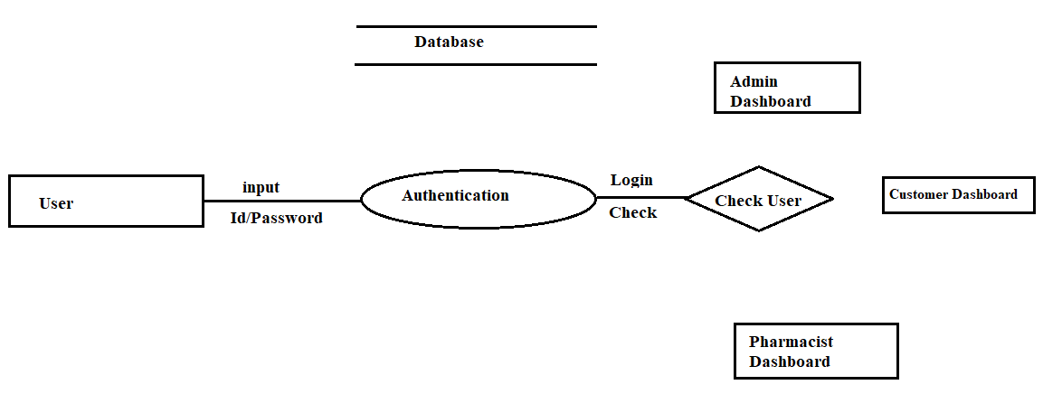

## **8.4 DFD Module for Admin Level:**

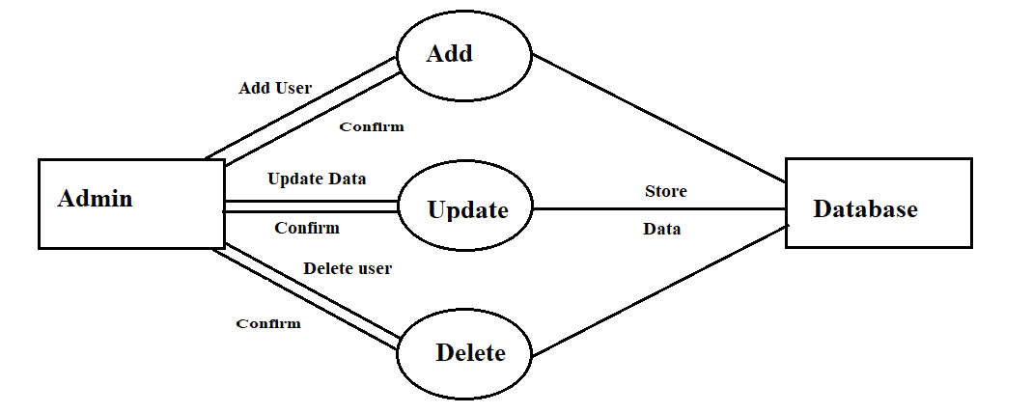

# 9. Table Design

CREATE TABLE `appuser` (

`appuser_pk` INT AUTO_INCREMENT PRIMARY KEY,

`userRole` ENUM('Customer', 'Admin', 'Pharmacist') NOT NULL,

`name` VARCHAR(200) NOT NULL,

`dob` DATE,

`mobileNumber` VARCHAR(20) UNIQUE,

`email` VARCHAR(200) UNIQUE,

`username` VARCHAR(200) UNIQUE,

`password` VARCHAR(255) NOT NULL,

`address` VARCHAR(200)

);

CREATE TABLE `medicine` (

`medicine_pk` INT AUTO_INCREMENT PRIMARY KEY,

`uniqueId` VARCHAR(200) UNIQUE,

`name` VARCHAR(200) NOT NULL,

`companyName` VARCHAR(200),

`quantity` INT DEFAULT 0,

`price` DECIMAL(10, 2)

);

CREATE TABLE `bill` (

`bill_pk` INT AUTO_INCREMENT PRIMARY KEY,

`billId` VARCHAR(200) UNIQUE,

`billDate` DATE,

`totalPaid` DECIMAL(10,2),

`generatedBy_fk` INT,

FOREIGN KEY (`generatedBy_fk`) REFERENCES `appuser`(`appuser_pk`) ON DELETE SET NULL

);

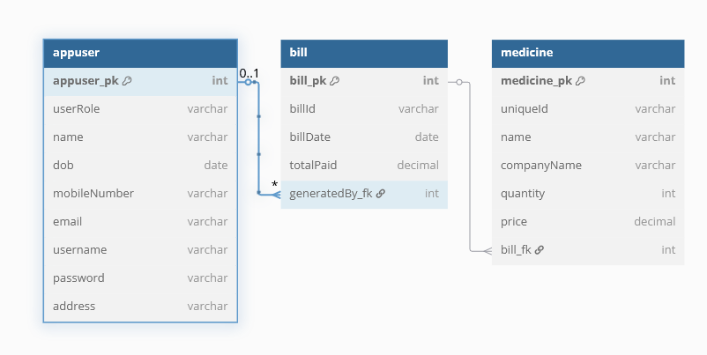

**9. Testing Methodology (Unit Testing, Integration Testing, etc.)**

|  |  |  |  |  |
| --- | --- | --- | --- | --- |
| Test Case ID | Scenario | Steps | Expected Result | Type |
| TC-ADM-001 | Admin Login with Valid Credentials | 1. Enter valid username/password2. Click Login | Admin logs in successfully | Positive |
| TC-CUS-006 | Purchase Medicine | 1. Select medicines2. Proceed to checkout3. Confirm purchase | Purchase completes; bill generated | Positive |
| TC-PHA-004 | Add Medicine with Missing Info | 1. Leave mandatory fields empty2. Submit form | Validation error shown; medicine not added | Negative |
| TC-ADM-010 | Unauthorized Admin Access | 1. Access admin module without login | Access denied; redirected to login | Security |

|  |  |  |  |  |  |
| --- | --- | --- | --- | --- | --- |
| ID | Module | Scenario | Steps | Expected Result | Type |
| TC-ADM-001 | Admin | Valid Admin Login | Enter valid credentials and submit | Admin successfully logged in | Positive |
| TC-CUS-002 | Customer | Registration with Invalid Data | Submit registration form with missing mandatory fields | Validation error displayed; registration fails | Negative |
| TC-CUS-006 | Customer | Purchase Medicine | Select medicines, proceed to checkout, confirm purchase | Purchase successful; bill generated | Positive |
| TC-PHA-003 | Pharmacist | Add New Medicine | Enter complete medicine details and save | Medicine added to inventory | Positive |
| TC-PHA-004 | Pharmacist | Add Medicine Missing Info | Submit medicine form with missing mandatory fields | Validation error displayed; medicine not added | Negative |
| TC-ADM-010 | Admin | Unauthorized Admin Access | Attempt to access admin panel without login | Access denied; redirected to login | Security |

# 10. Coding

## **Register.java**

import dao.ConnectionProvider;

import java.sql.Connection;

import java.sql.PreparedStatement;

import java.text.SimpleDateFormat;

import java.util.Date;

import javax.swing.JOptionPane;

public class Register extends javax.swing.JFrame {

public String emailPattern = "^[a-zA-Z0-9]+[@]+[a-zA-Z0-9]+[.]+[a-zA-Z0-9]+$";

public String mobileNumberPattern = "^[0-9]*$";

public int checkUsername = 0;

public Register() {

initComponents();

setLocationRelativeTo(null);

}

@SuppressWarnings("unchecked")

private void initComponents() {

jLabel1 = new javax.swing.JLabel();

jLabel2 = new javax.swing.JLabel();

txtName = new javax.swing.JTextField();

jLabel3 = new javax.swing.JLabel();

txtEmail = new javax.swing.JTextField();

jLabel4 = new javax.swing.JLabel();

jLabel5 = new javax.swing.JLabel();

comboUserRole = new javax.swing.JComboBox<>();

dateDOB = new com.toedter.calendar.JDateChooser();

jLabel6 = new javax.swing.JLabel();

jLabel7 = new javax.swing.JLabel();

jLabel8 = new javax.swing.JLabel();

jLabel9 = new javax.swing.JLabel();

txtMobileNumber = new javax.swing.JTextField();

txtAddress = new javax.swing.JTextField();

txtUsername = new javax.swing.JTextField();

txtPassword = new javax.swing.JTextField();

jButton1 = new javax.swing.JButton();

jLabel10 = new javax.swing.JLabel();

jButton2 = new javax.swing.JButton();

jButton3 = new javax.swing.JButton();

jLabel11 = new javax.swing.JLabel();

setDefaultCloseOperation(javax.swing.WindowConstants.EXIT_ON_CLOSE);

getContentPane().setLayout(new org.netbeans.lib.awtextra.AbsoluteLayout());

jLabel1.setFont(new java.awt.Font("Segoe UI", 1, 48));

jLabel1.setForeground(new java.awt.Color(255, 255, 255));

jLabel1.setText("Registration");

getContentPane().add(jLabel1, new org.netbeans.lib.awtextra.AbsoluteConstraints(780, 110, -1, -1));

jLabel2.setFont(new java.awt.Font("Segoe UI", 1, 14));

jLabel2.setForeground(new java.awt.Color(255, 255, 255));

jLabel2.setText("Name");

getContentPane().add(jLabel2, new org.netbeans.lib.awtextra.AbsoluteConstraints(520, 330, -1, -1));

txtName.setFont(new java.awt.Font("Segoe UI", 1, 14));

getContentPane().add(txtName, new org.netbeans.lib.awtextra.AbsoluteConstraints(520, 360, 300, -1));

jLabel3.setFont(new java.awt.Font("Segoe UI", 1, 14));

jLabel3.setForeground(new java.awt.Color(255, 255, 255));

jLabel3.setText("Email");

getContentPane().add(jLabel3, new org.netbeans.lib.awtextra.AbsoluteConstraints(520, 400, -1, -1));

txtEmail.setFont(new java.awt.Font("Segoe UI", 1, 14));

getContentPane().add(txtEmail, new org.netbeans.lib.awtextra.AbsoluteConstraints(520, 430, 300, -1));

jLabel4.setFont(new java.awt.Font("Segoe UI", 1, 14));

jLabel4.setForeground(new java.awt.Color(255, 255, 255));

jLabel4.setText("Date Of Birth(DOB)");

getContentPane().add(jLabel4, new org.netbeans.lib.awtextra.AbsoluteConstraints(950, 250, -1, -1));

jLabel5.setFont(new java.awt.Font("Segoe UI", 1, 14));

jLabel5.setForeground(new java.awt.Color(255, 255, 255));

jLabel5.setText("UserRole");

getContentPane().add(jLabel5, new org.netbeans.lib.awtextra.AbsoluteConstraints(520, 250, -1, -1));

comboUserRole.setModel(new javax.swing.DefaultComboBoxModel<>(new String[] { "Customer" }));

getContentPane().add(comboUserRole, new org.netbeans.lib.awtextra.AbsoluteConstraints(520, 290, 300, -1));

dateDOB.setFont(new java.awt.Font("Segoe UI", 1, 12));

getContentPane().add(dateDOB, new org.netbeans.lib.awtextra.AbsoluteConstraints(950, 290, 300, -1));

jLabel6.setFont(new java.awt.Font("Segoe UI", 1, 14));

jLabel6.setForeground(new java.awt.Color(255, 255, 255));

jLabel6.setText("Mobile Number");

getContentPane().add(jLabel6, new org.netbeans.lib.awtextra.AbsoluteConstraints(950, 330, -1, -1));

jLabel7.setFont(new java.awt.Font("Segoe UI", 1, 14));

jLabel7.setForeground(new java.awt.Color(255, 255, 255));

jLabel7.setText("Address");

getContentPane().add(jLabel7, new org.netbeans.lib.awtextra.AbsoluteConstraints(950, 400, -1, -1));

jLabel8.setFont(new java.awt.Font("Segoe UI", 1, 14));

jLabel8.setForeground(new java.awt.Color(255, 255, 255));

jLabel8.setText("Username");

getContentPane().add(jLabel8, new org.netbeans.lib.awtextra.AbsoluteConstraints(520, 470, -1, -1));

jLabel9.setFont(new java.awt.Font("Segoe UI", 1, 14));

jLabel9.setForeground(new java.awt.Color(255, 255, 255));

jLabel9.setText("Password");

getContentPane().add(jLabel9, new org.netbeans.lib.awtextra.AbsoluteConstraints(950, 470, -1, -1));

txtMobileNumber.setFont(new java.awt.Font("Segoe UI", 1, 14));

getContentPane().add(txtMobileNumber, new org.netbeans.lib.awtextra.AbsoluteConstraints(950, 360, 300, -1));

txtAddress.setFont(new java.awt.Font("Segoe UI", 1, 14));

getContentPane().add(txtAddress, new org.netbeans.lib.awtextra.AbsoluteConstraints(950, 430, 300, -1));

txtUsername.setFont(new java.awt.Font("Segoe UI", 1, 14));

getContentPane().add(txtUsername, new org.netbeans.lib.awtextra.AbsoluteConstraints(520, 510, 300, -1));

txtPassword.setFont(new java.awt.Font("Segoe UI", 1, 14));

getContentPane().add(txtPassword, new org.netbeans.lib.awtextra.AbsoluteConstraints(950, 510, 300, -1));

jButton1.setIcon(new javax.swing.ImageIcon(getClass().getResource("/images/pngwing.com(1).png")));

jButton1.addActionListener(new java.awt.event.ActionListener() {

public void actionPerformed(java.awt.event.ActionEvent evt) {

jButton1ActionPerformed(evt);

}

});

getContentPane().add(jButton1, new org.netbeans.lib.awtextra.AbsoluteConstraints(620, 580, -1, -1));

jLabel10.setFont(new java.awt.Font("Segoe UI", 1, 18));

jLabel10.setForeground(new java.awt.Color(255, 255, 255));

jLabel10.setText("Already have an account? ");

getContentPane().add(jLabel10, new org.netbeans.lib.awtextra.AbsoluteConstraints(910, 590, -1, 30));

jButton2.setFont(new java.awt.Font("Segoe UI", 1, 18));

jButton2.setIcon(new javax.swing.ImageIcon(getClass().getResource("/images/login.png")));

jButton2.setText("Login");

jButton2.addActionListener(new java.awt.event.ActionListener() {

public void actionPerformed(java.awt.event.ActionEvent evt) {

jButton2ActionPerformed(evt);

}

});

getContentPane().add(jButton2, new org.netbeans.lib.awtextra.AbsoluteConstraints(1140, 590, -1, -1));

jButton3.setIcon(new javax.swing.ImageIcon(getClass().getResource("/images/close.png")));

jButton3.addActionListener(new java.awt.event.ActionListener() {

public void actionPerformed(java.awt.event.ActionEvent evt) {

jButton3ActionPerformed(evt);

}

});

getContentPane().add(jButton3, new org.netbeans.lib.awtextra.AbsoluteConstraints(1298, 16, -1, -1));

jLabel11.setIcon(new javax.swing.ImageIcon(getClass().getResource("/images/login_background.PNG")));

getContentPane().add(jLabel11, new org.netbeans.lib.awtextra.AbsoluteConstraints(0, 0, -1, -1));

pack();

}

private void jButton2ActionPerformed(java.awt.event.ActionEvent evt) {

new Login().setVisible(true);

}

private void jButton3ActionPerformed(java.awt.event.ActionEvent evt) {

int a = JOptionPane.showConfirmDialog(null, "Do You want to close Application","Select",JOptionPane.YES_NO_OPTION);

if(a==0){

System.exit(0);

}

}

private void jButton1ActionPerformed(java.awt.event.ActionEvent evt) {

String userRole = (String) comboUserRole.getSelectedItem();

String name = txtName.getText();

SimpleDateFormat dFormat = new SimpleDateFormat("dd-MM-yyyy");

Date date = dateDOB.getDate();

String dob = "";

if(date !=null){

dob = dFormat.format(dateDOB.getDate());

}

String mobileNumber = txtMobileNumber.getText();

String email = txtEmail.getText();

String username = txtUsername.getText();

String password = txtPassword.getText();

String address = txtAddress.getText();

if(name.equals("")){

JOptionPane.showMessageDialog(null, "name field is required");

}else if(dob.equals("")){

JOptionPane.showMessageDialog(null, "Date of Birth field is required");

}else if(mobileNumber.equals("")){

JOptionPane.showMessageDialog(null, "Mobile Number field is required");

}else if(!mobileNumber.matches(mobileNumberPattern) || mobileNumber.length() != 10){

JOptionPane.showMessageDialog(null, "Mobile Number field is invalid");

}else if(email.equals("")){

JOptionPane.showMessageDialog(null, "Email field is required");

}else if(!email.matches(emailPattern)){

JOptionPane.showMessageDialog(null, "Email field is invalid");

}else if(username.equals("")){

JOptionPane.showMessageDialog(null, "Username field is required");

}else if(checkUsername == 1){

JOptionPane.showMessageDialog(null, "Username already exist.");

}else if(password.equals("") ){

JOptionPane.showMessageDialog(null, "Password field is required");

}else if(address.equals("")){

JOptionPane.showMessageDialog(null, "Address field is required");

}else{

try{

Connection con = ConnectionProvider.getCon();

PreparedStatement ps = con.prepareStatement("insert into appuser (userRole,name,dob,mobileNumber,email,username,password,address) values(?,?,?,?,?,?,?,?)");

ps.setString(1,userRole);

ps.setString(2,name);

ps.setString(3,dob);

ps.setString(4,mobileNumber);

ps.setString(5,email);

ps.setString(6,username);

ps.setString(7,password);

ps.setString(8,address);

ps.executeUpdate();

JOptionPane.showMessageDialog(null, "User Register Sucessfully");

setVisible(false);

new Login().setVisible(true);

}

catch(Exception e){

JOptionPane.showConfirmDialog(null, e);

}}

}

public static void main(String args[]) {

try {

for (javax.swing.UIManager.LookAndFeelInfo info : javax.swing.UIManager.getInstalledLookAndFeels()) {

if ("Nimbus".equals(info.getName())) {

javax.swing.UIManager.setLookAndFeel(info.getClassName());

break;

}

}

} catch (ClassNotFoundException ex) {

java.util.logging.Logger.getLogger(Register.class.getName()).log(java.util.logging.Level.SEVERE, null, ex);

} catch (InstantiationException ex) {

java.util.logging.Logger.getLogger(Register.class.getName()).log(java.util.logging.Level.SEVERE, null, ex);

} catch (IllegalAccessException ex) {

java.util.logging.Logger.getLogger(Register.class.getName()).log(java.util.logging.Level.SEVERE, null, ex);

} catch (javax.swing.UnsupportedLookAndFeelException ex) {

java.util.logging.Logger.getLogger(Register.class.getName()).log(java.util.logging.Level.SEVERE, null, ex);

}

java.awt.EventQueue.invokeLater(new Runnable() {

public void run() {

new Register().setVisible(true);

}

});

}

private javax.swing.JComboBox<String> comboUserRole;

private com.toedter.calendar.JDateChooser dateDOB;

private javax.swing.JButton jButton1;

private javax.swing.JButton jButton2;

private javax.swing.JButton jButton3;

private javax.swing.JLabel jLabel1;

private javax.swing.JLabel jLabel10;

private javax.swing.JLabel jLabel11;

private javax.swing.JLabel jLabel2;

private javax.swing.JLabel jLabel3;

private javax.swing.JLabel jLabel4;

private javax.swing.JLabel jLabel5;

private javax.swing.JLabel jLabel6;

private javax.swing.JLabel jLabel7;

private javax.swing.JLabel jLabel8;

private javax.swing.JLabel jLabel9;

private javax.swing.JTextField txtAddress;

private javax.swing.JTextField txtEmail;

private javax.swing.JTextField txtMobileNumber;

private javax.swing.JTextField txtName;

private javax.swing.JTextField txtPassword;

private javax.swing.JTextField txtUsername;

}

## **Login.java**

import javax.swing.JOptionPane;

import java.sql.Connection;

import dao.ConnectionProvider;

import java.sql.Statement;

import java.sql.ResultSet;

public class Login extends javax.swing.JFrame {

public Login() {

initComponents();

setLocationRelativeTo(null);

}

@SuppressWarnings("unchecked")

private void initComponents() {

jLabel1 = new javax.swing.JLabel();

jLabel2 = new javax.swing.JLabel();

txtUsername = new javax.swing.JTextField();

jLabel3 = new javax.swing.JLabel();

txtPassword = new javax.swing.JPasswordField();

jButton1 = new javax.swing.JButton();

jButton2 = new javax.swing.JButton();

jButton3 = new javax.swing.JButton();

jLabel4 = new javax.swing.JLabel();

jLabel5 = new javax.swing.JLabel();

setDefaultCloseOperation(javax.swing.WindowConstants.EXIT_ON_CLOSE);

getContentPane().setLayout(new org.netbeans.lib.awtextra.AbsoluteLayout());

jLabel1.setFont(new java.awt.Font("Segoe UI", 1, 48));

jLabel1.setForeground(new java.awt.Color(255, 255, 255));

jLabel1.setText("Login");

getContentPane().add(jLabel1, new org.netbeans.lib.awtextra.AbsoluteConstraints(710, 160, -1, -1));

jLabel2.setFont(new java.awt.Font("Segoe UI", 1, 18));

jLabel2.setForeground(new java.awt.Color(255, 255, 255));

jLabel2.setText("Username");

getContentPane().add(jLabel2, new org.netbeans.lib.awtextra.AbsoluteConstraints(520, 320, -1, -1));

txtUsername.setFont(new java.awt.Font("Segoe UI", 1, 18));

getContentPane().add(txtUsername, new org.netbeans.lib.awtextra.AbsoluteConstraints(620, 320, 300, -1));

jLabel3.setFont(new java.awt.Font("Segoe UI", 1, 18));

jLabel3.setForeground(new java.awt.Color(255, 255, 255));

jLabel3.setText("Password");

getContentPane().add(jLabel3, new org.netbeans.lib.awtextra.AbsoluteConstraints(520, 360, -1, -1));

txtPassword.setFont(new java.awt.Font("Segoe UI", 1, 18));

getContentPane().add(txtPassword, new org.netbeans.lib.awtextra.AbsoluteConstraints(620, 360, 300, -1));

jButton1.setFont(new java.awt.Font("Segoe UI", 1, 18));

jButton1.setIcon(new javax.swing.ImageIcon(getClass().getResource("/images/login.png")));

jButton1.setText("Login");

jButton1.addActionListener(new java.awt.event.ActionListener() {

public void actionPerformed(java.awt.event.ActionEvent evt) {

jButton1ActionPerformed(evt);

}

});

getContentPane().add(jButton1, new org.netbeans.lib.awtextra.AbsoluteConstraints(680, 420, 160, 40));

jButton2.setIcon(new javax.swing.ImageIcon(getClass().getResource("/images/close.png")));

jButton2.addActionListener(new java.awt.event.ActionListener() {

public void actionPerformed(java.awt.event.ActionEvent evt) {

jButton2ActionPerformed(evt);

}

});

getContentPane().add(jButton2, new org.netbeans.lib.awtextra.AbsoluteConstraints(1300, 20, -1, -1));

jButton3.setFont(new java.awt.Font("Segoe UI", 1, 14));

jButton3.setIcon(new javax.swing.ImageIcon(getClass().getResource("/images/pngwing.com(1).png")));

jButton3.addActionListener(new java.awt.event.ActionListener() {

public void actionPerformed(java.awt.event.ActionEvent evt) {

jButton3ActionPerformed(evt);

}

});

getContentPane().add(jButton3, new org.netbeans.lib.awtextra.AbsoluteConstraints(970, 520, -1, -1));

jLabel4.setFont(new java.awt.Font("Segoe UI", 1, 18));

jLabel4.setForeground(new java.awt.Color(255, 255, 255));

jLabel4.setText("New here? (Only For Customer Registration)");

getContentPane().add(jLabel4, new org.netbeans.lib.awtextra.AbsoluteConstraints(540, 540, 380, -1));

jLabel5.setIcon(new javax.swing.ImageIcon(getClass().getResource("/images/login_background.PNG")));

jLabel5.setText("jLabel5");

getContentPane().add(jLabel5, new org.netbeans.lib.awtextra.AbsoluteConstraints(0, 0, -1, -1));

pack();

}

private void jButton1ActionPerformed(java.awt.event.ActionEvent evt) {

String username = txtUsername.getText();

String password = txtPassword.getText();

int temp = 0;

try {

Connection con = ConnectionProvider.getCon();

Statement st = con.createStatement();

ResultSet rs = st.executeQuery("select * from appuser where username='" + username + "' and password='" + password + "'");

while (rs.next()) {

temp = 1;

String role = rs.getString("userRole");

setVisible(false); // Hide login window

if ("Admin".equalsIgnoreCase(role)) {

new AdminDashboard(username).setVisible(true);

} else if ("Pharmacist".equalsIgnoreCase(role)) {

new PharmacistDashboard(username).setVisible(true);

} else if ("Customer".equalsIgnoreCase(role)) {

new CustomerDashboard(username).setVisible(true);

} else {

JOptionPane.showMessageDialog(null, "Unrecognized user role: " + role);

setVisible(true); // Show login window again if role is unknown

}

}

if (temp == 0) {

JOptionPane.showMessageDialog(null, "Incorrect Username or Password");

}

} catch (Exception e) {

JOptionPane.showMessageDialog(null, e);

}

}

private void jButton2ActionPerformed(java.awt.event.ActionEvent evt) {

int a = JOptionPane.showConfirmDialog(null, "Do You want to close Application","Select",JOptionPane.YES_NO_OPTION);

if(a==0){

System.exit(0);

}

}

private void jButton3ActionPerformed(java.awt.event.ActionEvent evt) {

new Register().setVisible(true);

}

public static void main(String args[]) {

try {

for (javax.swing.UIManager.LookAndFeelInfo info : javax.swing.UIManager.getInstalledLookAndFeels()) {

if ("Nimbus".equals(info.getName())) {

javax.swing.UIManager.setLookAndFeel(info.getClassName());

break;

}

}

} catch (ClassNotFoundException ex) {

java.util.logging.Logger.getLogger(Login.class.getName()).log(java.util.logging.Level.SEVERE, null, ex);

} catch (InstantiationException ex) {

java.util.logging.Logger.getLogger(Login.class.getName()).log(java.util.logging.Level.SEVERE, null, ex);

} catch (IllegalAccessException ex) {

java.util.logging.Logger.getLogger(Login.class.getName()).log(java.util.logging.Level.SEVERE, null, ex);

} catch (javax.swing.UnsupportedLookAndFeelException ex) {

java.util.logging.Logger.getLogger(Login.class.getName()).log(java.util.logging.Level.SEVERE, null, ex);

}

java.awt.EventQueue.invokeLater(new Runnable() {

public void run() {

new Login().setVisible(true);

}

});

}

private javax.swing.JButton jButton1;

private javax.swing.JButton jButton2;

private javax.swing.JButton jButton3;

private javax.swing.JLabel jLabel1;

private javax.swing.JLabel jLabel2;

private javax.swing.JLabel jLabel3;

private javax.swing.JLabel jLabel4;

private javax.swing.JLabel jLabel5;

private javax.swing.JPasswordField txtPassword;

private javax.swing.JTextField txtUsername;

}

## **AdminDashboard.java**

import javax.swing.JOptionPane;

public class AdminDashboard extends javax.swing.JFrame {

private String username = "";

public AdminDashboard() {

initComponents();

}

public AdminDashboard(String tempUsername) {

initComponents();

username = tempUsername;

System.out.println(username);

setLocationRelativeTo(null);

}

@SuppressWarnings("unchecked")

private void initComponents() {

jLabel1 = new javax.swing.JLabel();

jSeparator1 = new javax.swing.JSeparator();

jButton1 = new javax.swing.JButton();

jButton2 = new javax.swing.JButton();

jButton3 = new javax.swing.JButton();

jButton4 = new javax.swing.JButton();

jButton5 = new javax.swing.JButton();

jButton6 = new javax.swing.JButton();

jLabel2 = new javax.swing.JLabel();

setDefaultCloseOperation(javax.swing.WindowConstants.EXIT_ON_CLOSE);

setUndecorated(true);

getContentPane().setLayout(new org.netbeans.lib.awtextra.AbsoluteLayout());

jLabel1.setFont(new java.awt.Font("Segoe UI", 1, 48));

jLabel1.setForeground(new java.awt.Color(255, 255, 255));

jLabel1.setText("Admin Dashboard");

getContentPane().add(jLabel1, new org.netbeans.lib.awtextra.AbsoluteConstraints(420, 40, -1, -1));

getContentPane().add(jSeparator1, new org.netbeans.lib.awtextra.AbsoluteConstraints(0, 130, 1373, 10));

jButton1.setFont(new java.awt.Font("Segoe UI", 1, 18));

jButton1.setIcon(new javax.swing.ImageIcon(getClass().getResource("/images/addUser.png")));

jButton1.setText("Add User");

jButton1.addActionListener(new java.awt.event.ActionListener() {

public void actionPerformed(java.awt.event.ActionEvent evt) {

jButton1ActionPerformed(evt);

}

});

getContentPane().add(jButton1, new org.netbeans.lib.awtextra.AbsoluteConstraints(350, 220, 239, -1));

jButton2.setFont(new java.awt.Font("Segoe UI", 1, 18));

jButton2.setIcon(new javax.swing.ImageIcon(getClass().getResource("/images/profile.png")));

jButton2.setText("Profile");

jButton2.addActionListener(new java.awt.event.ActionListener() {

public void actionPerformed(java.awt.event.ActionEvent evt) {

jButton2ActionPerformed(evt);

}

});

getContentPane().add(jButton2, new org.netbeans.lib.awtextra.AbsoluteConstraints(760, 220, -1, -1));

jButton3.setFont(new java.awt.Font("Segoe UI", 1, 18));

jButton3.setIcon(new javax.swing.ImageIcon(getClass().getResource("/images/viewUser.png")));

jButton3.setText("View User");

jButton3.addActionListener(new java.awt.event.ActionListener() {

public void actionPerformed(java.awt.event.ActionEvent evt) {

jButton3ActionPerformed(evt);

}

});

getContentPane().add(jButton3, new org.netbeans.lib.awtextra.AbsoluteConstraints(350, 340, 239, -1));

jButton4.setFont(new java.awt.Font("Segoe UI", 1, 18));

jButton4.setIcon(new javax.swing.ImageIcon(getClass().getResource("/images/logout.png")));

jButton4.setText("Logout");

jButton4.addActionListener(new java.awt.event.ActionListener() {

public void actionPerformed(java.awt.event.ActionEvent evt) {

jButton4ActionPerformed(evt);

}

});

getContentPane().add(jButton4, new org.netbeans.lib.awtextra.AbsoluteConstraints(760, 340, 270, -1));

jButton5.setFont(new java.awt.Font("Segoe UI", 1, 18));

jButton5.setIcon(new javax.swing.ImageIcon(getClass().getResource("/images/updateUser.png")));

jButton5.setText("Update User");

jButton5.addActionListener(new java.awt.event.ActionListener() {

public void actionPerformed(java.awt.event.ActionEvent evt) {

jButton5ActionPerformed(evt);

}

});

getContentPane().add(jButton5, new org.netbeans.lib.awtextra.AbsoluteConstraints(350, 460, -1, -1));

jButton6.setFont(new java.awt.Font("Segoe UI", 1, 18));

jButton6.setIcon(new javax.swing.ImageIcon(getClass().getResource("/images/exit.png")));

jButton6.setText("Exit");

jButton6.addActionListener(new java.awt.event.ActionListener() {

public void actionPerformed(java.awt.event.ActionEvent evt) {

jButton6ActionPerformed(evt);

}

});

getContentPane().add(jButton6, new org.netbeans.lib.awtextra.AbsoluteConstraints(760, 460, 270, -1));

jLabel2.setIcon(new javax.swing.ImageIcon(getClass().getResource("/images/adminDashboardBackground.png")));

jLabel2.setText("jLabel2");

getContentPane().add(jLabel2, new org.netbeans.lib.awtextra.AbsoluteConstraints(0, -60, 1370, 900));

pack();

}

private void jButton3ActionPerformed(java.awt.event.ActionEvent evt) {

new ViewUser(username).setVisible(true);

}

private void jButton4ActionPerformed(java.awt.event.ActionEvent evt) {

int a = JOptionPane.showConfirmDialog(null, "Do you want to Logout","Select",JOptionPane.YES_NO_OPTION);

if(a==0) {

setVisible(false);

new Login().setVisible(true);

}

}

private void jButton6ActionPerformed(java.awt.event.ActionEvent evt) {

int a = JOptionPane.showConfirmDialog(null, "Do you want to Close Application","Select",JOptionPane.YES_NO_CANCEL_OPTION);

if (a == JOptionPane.YES_OPTION) {

System.exit(0);

}

}

private void jButton1ActionPerformed(java.awt.event.ActionEvent evt) {

new AddUser().setVisible(true);

}

private void jButton5ActionPerformed(java.awt.event.ActionEvent evt) {

new UpdateUser().setVisible(true);

}

private void jButton2ActionPerformed(java.awt.event.ActionEvent evt) {

new Profile(username).setVisible(true);

}

public static void main(String args[]) {

try {

for (javax.swing.UIManager.LookAndFeelInfo info : javax.swing.UIManager.getInstalledLookAndFeels()) {

if ("Nimbus".equals(info.getName())) {

javax.swing.UIManager.setLookAndFeel(info.getClassName());

break;

}

}

} catch (ClassNotFoundException ex) { java.util.logging.Logger.getLogger(AdminDashboard.class.getName()).log(java.util.logging.Level.SEVERE, null, ex);

} catch (InstantiationException ex) {

java.util.logging.Logger.getLogger(AdminDashboard.class.getName()).log(java.util.logging.Level.SEVERE, null, ex);

} catch (IllegalAccessException ex) {

java.util.logging.Logger.getLogger(AdminDashboard.class.getName()).log(java.util.logging.Level.SEVERE, null, ex);

} catch (javax.swing.UnsupportedLookAndFeelException ex) {

java.util.logging.Logger.getLogger(AdminDashboard.class.getName()).log(java.util.logging.Level.SEVERE, null, ex);

}

java.awt.EventQueue.invokeLater(new Runnable() {

public void run() {

new AdminDashboard().setVisible(true);

}

});

}

private javax.swing.JButton jButton1;

private javax.swing.JButton jButton2;

private javax.swing.JButton jButton3;

private javax.swing.JButton jButton4;

private javax.swing.JButton jButton5;

private javax.swing.JButton jButton6;

private javax.swing.JLabel jLabel1;

private javax.swing.JLabel jLabel2;

private javax.swing.JSeparator jSeparator1;

}

## **PharmacyDashboard.java**

import javax.swing.JOptionPane;

public class PharmacistDashboard extends javax.swing.JFrame {

private String username = "";

public PharmacistDashboard() {

initComponents();

}

public PharmacistDashboard(String tempUsername) {

initComponents();

username = tempUsername;

setLocationRelativeTo(null);

}

@SuppressWarnings("unchecked")

private void initComponents() {

jLabel1 = new javax.swing.JLabel();

jSeparator1 = new javax.swing.JSeparator();

jButton1 = new javax.swing.JButton();

jButton2 = new javax.swing.JButton();

jButton3 = new javax.swing.JButton();

jButton4 = new javax.swing.JButton();

jButton5 = new javax.swing.JButton();

jButton6 = new javax.swing.JButton();

jButton7 = new javax.swing.JButton();

jButton8 = new javax.swing.JButton();

jButton10 = new javax.swing.JButton();

jLabel2 = new javax.swing.JLabel();

setDefaultCloseOperation(javax.swing.WindowConstants.EXIT_ON_CLOSE);

setUndecorated(true);

getContentPane().setLayout(new org.netbeans.lib.awtextra.AbsoluteLayout());

jLabel1.setFont(new java.awt.Font("Segoe UI", 1, 48));

jLabel1.setForeground(new java.awt.Color(255, 255, 255));

jLabel1.setText("Pharmacist Dashboard");

getContentPane().add(jLabel1, new org.netbeans.lib.awtextra.AbsoluteConstraints(390, 10, -1, -1));

getContentPane().add(jSeparator1, new org.netbeans.lib.awtextra.AbsoluteConstraints(0, 76, 1366, 10));

jButton1.setFont(new java.awt.Font("Segoe UI", 1, 18));

jButton1.setIcon(new javax.swing.ImageIcon(getClass().getResource("/images/addMedicine.png")));

jButton1.setText("Add Medicine");

jButton1.addActionListener(new java.awt.event.ActionListener() {

public void actionPerformed(java.awt.event.ActionEvent evt) {

jButton1ActionPerformed(evt);

}

});

getContentPane().add(jButton1, new org.netbeans.lib.awtextra.AbsoluteConstraints(311, 124, 279, -1));

jButton2.setFont(new java.awt.Font("Segoe UI", 1, 18));

jButton2.setIcon(new javax.swing.ImageIcon(getClass().getResource("/images/viewUser.png")));

jButton2.setText("View Medicine");

jButton2.addActionListener(new java.awt.event.ActionListener() {

public void actionPerformed(java.awt.event.ActionEvent evt) {

jButton2ActionPerformed(evt);

}

});

getContentPane().add(jButton2, new org.netbeans.lib.awtextra.AbsoluteConstraints(311, 249, 279, -1));

jButton3.setFont(new java.awt.Font("Segoe UI", 1, 18));

jButton3.setIcon(new javax.swing.ImageIcon(getClass().getResource("/images/updateUser.png")));

jButton3.setText("Update Medicine");

jButton3.addActionListener(new java.awt.event.ActionListener() {

public void actionPerformed(java.awt.event.ActionEvent evt) {

jButton3ActionPerformed(evt);

}

});

getContentPane().add(jButton3, new org.netbeans.lib.awtextra.AbsoluteConstraints(311, 374, -1, -1));

jButton4.setFont(new java.awt.Font("Segoe UI", 1, 18));

jButton4.setIcon(new javax.swing.ImageIcon(getClass().getResource("/images/logout.png")));

jButton4.setText("Logout");

jButton4.addActionListener(new java.awt.event.ActionListener() {

public void actionPerformed(java.awt.event.ActionEvent evt) {

jButton4ActionPerformed(evt);

}

});

getContentPane().add(jButton4, new org.netbeans.lib.awtextra.AbsoluteConstraints(310, 610, 279, -1));

jButton5.setFont(new java.awt.Font("Segoe UI", 1, 18));

jButton5.setIcon(new javax.swing.ImageIcon(getClass().getResource("/images/sellMedicine.png")));

jButton5.setText("Sell Medicine");

jButton5.addActionListener(new java.awt.event.ActionListener() {

public void actionPerformed(java.awt.event.ActionEvent evt) {

jButton5ActionPerformed(evt);

}

});

getContentPane().add(jButton5, new org.netbeans.lib.awtextra.AbsoluteConstraints(864, 124, 279, -1));

jButton6.setFont(new java.awt.Font("Segoe UI", 1, 18));

jButton6.setIcon(new javax.swing.ImageIcon(getClass().getResource("/images/viewBill.png")));

jButton6.setText("View Bill");

jButton6.addActionListener(new java.awt.event.ActionListener() {

public void actionPerformed(java.awt.event.ActionEvent evt) {

jButton6ActionPerformed(evt);

}

});

getContentPane().add(jButton6, new org.netbeans.lib.awtextra.AbsoluteConstraints(864, 249, 279, -1));

jButton7.setFont(new java.awt.Font("Segoe UI", 1, 18));

jButton7.setIcon(new javax.swing.ImageIcon(getClass().getResource("/images/profile.png")));

jButton7.setText("Profile");

jButton7.addActionListener(new java.awt.event.ActionListener() {

public void actionPerformed(java.awt.event.ActionEvent evt) {

jButton7ActionPerformed(evt);

}

});

getContentPane().add(jButton7, new org.netbeans.lib.awtextra.AbsoluteConstraints(864, 374, 279, -1));

jButton8.setFont(new java.awt.Font("Segoe UI", 1, 18));

jButton8.setIcon(new javax.swing.ImageIcon(getClass().getResource("/images/exit.png")));

jButton8.setText("Exit");

jButton8.addActionListener(new java.awt.event.ActionListener() {

public void actionPerformed(java.awt.event.ActionEvent evt) {

jButton8ActionPerformed(evt);

}

});

getContentPane().add(jButton8, new org.netbeans.lib.awtextra.AbsoluteConstraints(860, 610, 279, -1));

jButton10.setFont(new java.awt.Font("Segoe UI", 1, 18));

jButton10.setIcon(new javax.swing.ImageIcon(getClass().getResource("/images/viewUser.png")));

jButton10.setText("View Customer");

jButton10.addActionListener(new java.awt.event.ActionListener() {

public void actionPerformed(java.awt.event.ActionEvent evt) {

jButton10ActionPerformed(evt);

}

});

getContentPane().add(jButton10, new org.netbeans.lib.awtextra.AbsoluteConstraints(600, 490, -1, -1));

jLabel2.setIcon(new javax.swing.ImageIcon(getClass().getResource("/images/adminDashboardBackground.png")));

getContentPane().add(jLabel2, new org.netbeans.lib.awtextra.AbsoluteConstraints(0, 0, -1, -1));

pack();

}

private void jButton4ActionPerformed(java.awt.event.ActionEvent evt) {

int a = JOptionPane.showConfirmDialog(null, "Do you want to Logout","Select",JOptionPane.YES_NO_OPTION);

if(a==0){

setVisible(false);

new Login().setVisible(true);

}

}

private void jButton8ActionPerformed(java.awt.event.ActionEvent evt) {

int a = JOptionPane.showConfirmDialog(null, "Do you want to Close Application","Select",JOptionPane.YES_NO_OPTION);

if(a==0){

setVisible(false);

System.exit(a);

}

}

private void jButton7ActionPerformed(java.awt.event.ActionEvent evt) {

new Profile(username).setVisible(true);

}

private void jButton1ActionPerformed(java.awt.event.ActionEvent evt) {

new AddMedicine().setVisible(true);

}

private void jButton2ActionPerformed(java.awt.event.ActionEvent evt) {

new ViewMedicine().setVisible(true);

}

private void jButton3ActionPerformed(java.awt.event.ActionEvent evt) {

new UpdateMedicine().setVisible(true);

}

private void jButton5ActionPerformed(java.awt.event.ActionEvent evt) {

new SellMedicine(username).setVisible(true);

}

private void jButton6ActionPerformed(java.awt.event.ActionEvent evt) {

new ViewBill("Pharmacist",username).setVisible(true);

}

private void jButton10ActionPerformed(java.awt.event.ActionEvent evt) {

new ViewCustomer(username).setVisible(true);

}

public static void main(String args[]) {

try {

for (javax.swing.UIManager.LookAndFeelInfo info : javax.swing.UIManager.getInstalledLookAndFeels()) {

if ("Nimbus".equals(info.getName())) {

javax.swing.UIManager.setLookAndFeel(info.getClassName());

break;

}

}

} catch (ClassNotFoundException ex) { java.util.logging.Logger.getLogger(PharmacistDashboard.class.getName()).log(java.util.logging.Level.SEVERE, null, ex);

} catch (InstantiationException ex) { java.util.logging.Logger.getLogger(PharmacistDashboard.class.getName()).log(java.util.logging.Level.SEVERE, null, ex);

} catch (IllegalAccessException ex) { java.util.logging.Logger.getLogger(PharmacistDashboard.class.getName()).log(java.util.logging.Level.SEVERE, null, ex);

} catch (javax.swing.UnsupportedLookAndFeelException ex) {

java.util.logging.Logger.getLogger(PharmacistDashboard.class.getName()).log(java.util.logging.Level.SEVERE, null, ex);

}

java.awt.EventQueue.invokeLater(new Runnable() {

public void run() {

new PharmacistDashboard().setVisible(true);

}

});

}

private javax.swing.JButton jButton1;

private javax.swing.JButton jButton10;

private javax.swing.JButton jButton2;

private javax.swing.JButton jButton3;

private javax.swing.JButton jButton4;

private javax.swing.JButton jButton5;

private javax.swing.JButton jButton6;

private javax.swing.JButton jButton7;

private javax.swing.JButton jButton8;

private javax.swing.JLabel jLabel1;

private javax.swing.JLabel jLabel2;

private javax.swing.JSeparator jSeparator1;

}

## **CustomerDashboard.java**

import javax.swing.JOptionPane;

public class CustomerDashboard extends javax.swing.JFrame {

private String username = "";

public CustomerDashboard() {

initComponents();

}

public CustomerDashboard(String tempUsername) {

initComponents();

username = tempUsername;

setLocationRelativeTo(null);

}

@SuppressWarnings("unchecked")

private void initComponents() {

jLabel1 = new javax.swing.JLabel();

jSeparator1 = new javax.swing.JSeparator();

jButton2 = new javax.swing.JButton();

jButton3 = new javax.swing.JButton();

jButton5 = new javax.swing.JButton();

jButton6 = new javax.swing.JButton();

jButton7 = new javax.swing.JButton();

setDefaultCloseOperation(javax.swing.WindowConstants.EXIT_ON_CLOSE);

setUndecorated(true);

jLabel1.setFont(new java.awt.Font("Segoe UI", 1, 36));

jLabel1.setText("Customer Dashboard");

jButton2.setFont(new java.awt.Font("Segoe UI", 1, 18));

jButton2.setIcon(new javax.swing.ImageIcon(getClass().getResource("/images/sellMedicine.png")));

jButton2.setText("Buy Medicine");

jButton2.addActionListener(new java.awt.event.ActionListener() {

public void actionPerformed(java.awt.event.ActionEvent evt) {

jButton2ActionPerformed(evt);

}

});

jButton3.setFont(new java.awt.Font("Segoe UI", 1, 18));

jButton3.setIcon(new javax.swing.ImageIcon(getClass().getResource("/images/profile.png")));

jButton3.setText("Profile");

jButton3.addActionListener(new java.awt.event.ActionListener() {

public void actionPerformed(java.awt.event.ActionEvent evt) {

jButton3ActionPerformed(evt);

}

});

jButton5.setFont(new java.awt.Font("Segoe UI", 1, 18));

jButton5.setIcon(new javax.swing.ImageIcon(getClass().getResource("/images/viewBill.png")));

jButton5.setText("View Bills");

jButton5.addActionListener(new java.awt.event.ActionListener() {

public void actionPerformed(java.awt.event.ActionEvent evt) {

jButton5ActionPerformed(evt);

}

});

jButton6.setFont(new java.awt.Font("Segoe UI", 1, 18));

jButton6.setIcon(new javax.swing.ImageIcon(getClass().getResource("/images/logout.png")));

jButton6.setText("Log Out");

jButton6.addActionListener(new java.awt.event.ActionListener() {

public void actionPerformed(java.awt.event.ActionEvent evt) {

jButton6ActionPerformed(evt);

}

});

jButton7.setFont(new java.awt.Font("Segoe UI", 1, 18));

jButton7.setIcon(new javax.swing.ImageIcon(getClass().getResource("/images/exit.png")));

jButton7.setText("Exit");

jButton7.addActionListener(new java.awt.event.ActionListener() {

public void actionPerformed(java.awt.event.ActionEvent evt) {

jButton7ActionPerformed(evt);

}

});

javax.swing.GroupLayout layout = new javax.swing.GroupLayout(getContentPane());

getContentPane().setLayout(layout);

layout.setHorizontalGroup(

layout.createParallelGroup(javax.swing.GroupLayout.Alignment.LEADING)

.addGroup(layout.createSequentialGroup()

.addContainerGap(javax.swing.GroupLayout.DEFAULT_SIZE, Short.MAX_VALUE)

.addComponent(jLabel1)

.addGap(510, 510, 510))

.addComponent(jSeparator1)

.addGroup(layout.createSequentialGroup()

.addGap(261, 261, 261)

.addGroup(layout.createParallelGroup(javax.swing.GroupLayout.Alignment.LEADING, false)

.addComponent(jButton2, javax.swing.GroupLayout.DEFAULT_SIZE, 300, Short.MAX_VALUE)

.addComponent(jButton5, javax.swing.GroupLayout.DEFAULT_SIZE, javax.swing.GroupLayout.DEFAULT_SIZE, Short.MAX_VALUE))

.addPreferredGap(javax.swing.LayoutStyle.ComponentPlacement.RELATED, 219, Short.MAX_VALUE)

.addGroup(layout.createParallelGroup(javax.swing.GroupLayout.Alignment.LEADING, false)

.addComponent(jButton6, javax.swing.GroupLayout.DEFAULT_SIZE, javax.swing.GroupLayout.DEFAULT_SIZE, Short.MAX_VALUE)

.addComponent(jButton3, javax.swing.GroupLayout.DEFAULT_SIZE, 300, Short.MAX_VALUE))

.addGap(286, 286, 286))

.addGroup(layout.createSequentialGroup()

.addGap(538, 538, 538)

.addComponent(jButton7, javax.swing.GroupLayout.PREFERRED_SIZE, 270, javax.swing.GroupLayout.PREFERRED_SIZE)

.addContainerGap(javax.swing.GroupLayout.DEFAULT_SIZE, Short.MAX_VALUE))

);

layout.setVerticalGroup(

layout.createParallelGroup(javax.swing.GroupLayout.Alignment.LEADING)

.addGroup(layout.createSequentialGroup()

.addContainerGap()

.addComponent(jLabel1)

.addPreferredGap(javax.swing.LayoutStyle.ComponentPlacement.UNRELATED)

.addComponent(jSeparator1, javax.swing.GroupLayout.PREFERRED_SIZE, 10, javax.swing.GroupLayout.PREFERRED_SIZE)

.addGap(90, 90, 90)

.addGroup(layout.createParallelGroup(javax.swing.GroupLayout.Alignment.BASELINE)

.addComponent(jButton2)

.addComponent(jButton3))

.addGap(30, 30, 30)

.addGroup(layout.createParallelGroup(javax.swing.GroupLayout.Alignment.BASELINE)

.addComponent(jButton5)

.addComponent(jButton6))

.addGap(58, 58, 58)

.addComponent(jButton7)

.addContainerGap(193, Short.MAX_VALUE))

);

pack();

}

private void jButton6ActionPerformed(java.awt.event.ActionEvent evt) {

int a = JOptionPane.showConfirmDialog(null, "Do you want to Logout","Select",JOptionPane.YES_NO_OPTION);

if(a==0){

setVisible(false);

new Login().setVisible(true);

}

}

private void jButton7ActionPerformed(java.awt.event.ActionEvent evt) {

int a = JOptionPane.showConfirmDialog(null, "Do you want to Close Application","Select",JOptionPane.YES_NO_OPTION);

if(a==0){

setVisible(false);

System.exit(a);

}

}

private void jButton2ActionPerformed(java.awt.event.ActionEvent evt) {

new SellMedicine(username).setVisible(true);

}

private void jButton5ActionPerformed(java.awt.event.ActionEvent evt) {

new ViewBill("Customer",username).setVisible(true);

}

private void jButton3ActionPerformed(java.awt.event.ActionEvent evt) {

new Profile(username).setVisible(true);

}

public static void main(String args[]) {

try {

for (javax.swing.UIManager.LookAndFeelInfo info : javax.swing.UIManager.getInstalledLookAndFeels()) {

if ("Nimbus".equals(info.getName())) {

javax.swing.UIManager.setLookAndFeel(info.getClassName());

break;

}

}

} catch (ClassNotFoundException ex) {

java.util.logging.Logger.getLogger(CustomerDashboard.class.getName()).log(java.util.logging.Level.SEVERE, null, ex);

} catch (InstantiationException ex) { java.util.logging.Logger.getLogger(CustomerDashboard.class.getName()).log(java.util.logging.Level.SEVERE, null, ex);

} catch (IllegalAccessException ex) {

java.util.logging.Logger.getLogger(CustomerDashboard.class.getName()).log(java.util.logging.Level.SEVERE, null, ex);

} catch (javax.swing.UnsupportedLookAndFeelException ex) { java.util.logging.Logger.getLogger(CustomerDashboard.class.getName()).log(java.util.logging.Level.SEVERE, null, ex);

}

java.awt.EventQueue.invokeLater(new Runnable() {

public void run() {

new CustomerDashboard().setVisible(true);

}

});

}

private javax.swing.JButton jButton2;

private javax.swing.JButton jButton3;

private javax.swing.JButton jButton5;

private javax.swing.JButton jButton6;

private javax.swing.JButton jButton7;

private javax.swing.JLabel jLabel1;

private javax.swing.JSeparator jSeparator1;

}

## **AddUser.java**

import dao.ConnectionProvider;

import java.sql.Connection;

import java.sql.PreparedStatement;

import java.sql.ResultSet;

import java.sql.*;

import java.text.SimpleDateFormat;

import javax.swing.ImageIcon;

import javax.swing.JOptionPane;

import java.util.Date;

import java.util.*;

public class AddUser extends javax.swing.JFrame {

public String emailPattern = "^[a-zA-Z0-9]+[@]+[a-zA-Z0-9]+[.]+[a-zA-Z0-9]+$";

public String mobileNumberPattern = "^[0-9]*$";

public int checkUsername = 0;

public AddUser() {

initComponents();

iconLabel.setVisible(false);

setLocationRelativeTo(null);

}

@SuppressWarnings("unchecked")

private void initComponents() {

jLabel1 = new javax.swing.JLabel();

jSeparator1 = new javax.swing.JSeparator();

jLabel2 = new javax.swing.JLabel();

comboUserRole = new javax.swing.JComboBox<>();

jLabel3 = new javax.swing.JLabel();

txtName = new javax.swing.JTextField();

jLabel4 = new javax.swing.JLabel();

dateDOB = new com.toedter.calendar.JDateChooser();

jLabel5 = new javax.swing.JLabel();

txtMobileNumber = new javax.swing.JTextField();

jLabel6 = new javax.swing.JLabel();

txtEmail = new javax.swing.JTextField();

jLabel7 = new javax.swing.JLabel();

txtUsername = new javax.swing.JTextField();

iconLabel = new javax.swing.JLabel();

jLabel9 = new javax.swing.JLabel();

txtPassword = new javax.swing.JTextField();

jLabel10 = new javax.swing.JLabel();

txtAddress = new javax.swing.JTextField();

jButton1 = new javax.swing.JButton();

jButton2 = new javax.swing.JButton();

jLabel11 = new javax.swing.JLabel();

setDefaultCloseOperation(javax.swing.WindowConstants.EXIT_ON_CLOSE);

setUndecorated(true);

jLabel1.setFont(new java.awt.Font("Segoe UI", 1, 36));

jLabel1.setText("Add User");

jLabel2.setFont(new java.awt.Font("Segoe UI", 1, 12));

jLabel2.setText("User Role");

comboUserRole.setFont(new java.awt.Font("Segoe UI", 1, 12));

comboUserRole.setModel(new javax.swing.DefaultComboBoxModel<>(new String[] { "Admin", "Pharmacist", "Customer" }));

jLabel3.setFont(new java.awt.Font("Segoe UI", 1, 12));

jLabel3.setText("Name");

txtName.setFont(new java.awt.Font("Segoe UI", 1, 12));

jLabel4.setFont(new java.awt.Font("Segoe UI", 1, 12));

jLabel4.setText("DOB (Date Of Birth)");

dateDOB.setFocusable(false);

dateDOB.setFont(new java.awt.Font("Segoe UI", 1, 12));

jLabel5.setFont(new java.awt.Font("Segoe UI", 1, 12));

jLabel5.setText("Mobile Number");

txtMobileNumber.setFont(new java.awt.Font("Segoe UI", 1, 12));

jLabel6.setFont(new java.awt.Font("Segoe UI", 1, 12));

jLabel6.setText("Email");

txtEmail.setFont(new java.awt.Font("Segoe UI", 1, 12));

jLabel7.setFont(new java.awt.Font("Segoe UI", 1, 12));

jLabel7.setText("Username");

txtUsername.setFont(new java.awt.Font("Segoe UI", 1, 12));

txtUsername.addKeyListener(new java.awt.event.KeyAdapter() {

public void keyReleased(java.awt.event.KeyEvent evt) {

txtUsernameKeyReleased(evt);

}

});

iconLabel.setText("jLabel8");

jLabel9.setFont(new java.awt.Font("Segoe UI", 1, 12));

jLabel9.setText("Password");

txtPassword.setFont(new java.awt.Font("Segoe UI", 1, 12));

jLabel10.setFont(new java.awt.Font("Segoe UI", 1, 12));

jLabel10.setText("Address");

txtAddress.setFont(new java.awt.Font("Segoe UI", 1, 12));

jButton1.setFont(new java.awt.Font("Segoe UI", 1, 12));

jButton1.setIcon(new javax.swing.ImageIcon(getClass().getResource("/images/save.png")));

jButton1.setText("Save");

jButton1.addActionListener(new java.awt.event.ActionListener() {

public void actionPerformed(java.awt.event.ActionEvent evt) {

jButton1ActionPerformed(evt);

}

});

jButton2.setIcon(new javax.swing.ImageIcon(getClass().getResource("/images/close.png")));

jButton2.addActionListener(new java.awt.event.ActionListener() {

public void actionPerformed(java.awt.event.ActionEvent evt) {

jButton2ActionPerformed(evt);

}

});

jLabel11.setIcon(new javax.swing.ImageIcon(getClass().getResource("/images/all_pages_background.png")));

jLabel11.setText("jLabel11");

javax.swing.GroupLayout layout = new javax.swing.GroupLayout(getContentPane());

getContentPane().setLayout(layout);

layout.setHorizontalGroup(

layout.createParallelGroup(javax.swing.GroupLayout.Alignment.LEADING)

.addComponent(jSeparator1, javax.swing.GroupLayout.PREFERRED_SIZE, 850, javax.swing.GroupLayout.PREFERRED_SIZE)

.addGroup(layout.createSequentialGroup()

.addGap(449, 449, 449)

.addComponent(jButton1))

.addGroup(layout.createSequentialGroup()

.addGap(449, 449, 449)

.addComponent(jLabel7))

.addGroup(layout.createSequentialGroup()

.addGap(449, 449, 449)

.addComponent(txtUsername, javax.swing.GroupLayout.PREFERRED_SIZE, 300, javax.swing.GroupLayout.PREFERRED_SIZE))

.addGroup(layout.createSequentialGroup()

.addGap(449, 449, 449)

.addComponent(txtAddress, javax.swing.GroupLayout.PREFERRED_SIZE, 300, javax.swing.GroupLayout.PREFERRED_SIZE))

.addGroup(layout.createSequentialGroup()

.addGap(790, 790, 790)

.addComponent(jButton2))

.addGroup(layout.createSequentialGroup()

.addGap(449, 449, 449)

.addComponent(txtPassword, javax.swing.GroupLayout.PREFERRED_SIZE, 300, javax.swing.GroupLayout.PREFERRED_SIZE))

.addGroup(layout.createSequentialGroup()

.addGap(68, 68, 68)

.addComponent(comboUserRole, javax.swing.GroupLayout.PREFERRED_SIZE, 300, javax.swing.GroupLayout.PREFERRED_SIZE))

.addGroup(layout.createSequentialGroup()

.addGap(449, 449, 449)

.addComponent(jLabel6))

.addGroup(layout.createSequentialGroup()

.addGap(449, 449, 449)

.addComponent(txtEmail, javax.swing.GroupLayout.PREFERRED_SIZE, 300, javax.swing.GroupLayout.PREFERRED_SIZE))

.addGroup(layout.createSequentialGroup()

.addGap(68, 68, 68)

.addComponent(jLabel3))

.addGroup(layout.createSequentialGroup()

.addGap(68, 68, 68)

.addComponent(dateDOB, javax.swing.GroupLayout.PREFERRED_SIZE, 300, javax.swing.GroupLayout.PREFERRED_SIZE))

.addGroup(layout.createSequentialGroup()

.addGap(68, 68, 68)

.addComponent(txtMobileNumber, javax.swing.GroupLayout.PREFERRED_SIZE, 300, javax.swing.GroupLayout.PREFERRED_SIZE))

.addGroup(layout.createSequentialGroup()

.addGap(449, 449, 449)

.addComponent(jLabel9))

.addGroup(layout.createSequentialGroup()

.addGap(68, 68, 68)

.addComponent(jLabel5))

.addGroup(layout.createSequentialGroup()

.addGap(449, 449, 449)

.addComponent(jLabel10))

.addGroup(layout.createSequentialGroup()

.addGap(767, 767, 767)

.addComponent(iconLabel))

.addGroup(layout.createSequentialGroup()

.addGap(338, 338, 338)

.addComponent(jLabel1))

.addGroup(layout.createSequentialGroup()

.addGap(68, 68, 68)

.addComponent(jLabel2))

.addGroup(layout.createSequentialGroup()

.addGap(68, 68, 68)

.addComponent(jLabel4))

.addGroup(layout.createSequentialGroup()

.addGap(68, 68, 68)

.addComponent(txtName, javax.swing.GroupLayout.PREFERRED_SIZE, 300, javax.swing.GroupLayout.PREFERRED_SIZE))

.addComponent(jLabel11, javax.swing.GroupLayout.PREFERRED_SIZE, 850, javax.swing.GroupLayout.PREFERRED_SIZE)

);

layout.setVerticalGroup(

layout.createParallelGroup(javax.swing.GroupLayout.Alignment.LEADING)

.addGroup(layout.createSequentialGroup()

.addGap(60, 60, 60)

.addComponent(jSeparator1, javax.swing.GroupLayout.PREFERRED_SIZE, 10, javax.swing.GroupLayout.PREFERRED_SIZE)

.addGap(335, 335, 335)

.addComponent(jButton1))

.addGroup(layout.createSequentialGroup()

.addGap(183, 183, 183)

.addComponent(jLabel7))

.addGroup(layout.createSequentialGroup()

.addGap(217, 217, 217)

.addComponent(txtUsername, javax.swing.GroupLayout.PREFERRED_SIZE, javax.swing.GroupLayout.DEFAULT_SIZE, javax.swing.GroupLayout.PREFERRED_SIZE))

.addGroup(layout.createSequentialGroup()

.addGap(365, 365, 365)

.addComponent(txtAddress, javax.swing.GroupLayout.PREFERRED_SIZE, javax.swing.GroupLayout.DEFAULT_SIZE, javax.swing.GroupLayout.PREFERRED_SIZE))

.addGroup(layout.createSequentialGroup()

.addGap(20, 20, 20)

.addComponent(jButton2))

.addGroup(layout.createSequentialGroup()

.addGap(291, 291, 291)

.addComponent(txtPassword, javax.swing.GroupLayout.PREFERRED_SIZE, javax.swing.GroupLayout.DEFAULT_SIZE, javax.swing.GroupLayout.PREFERRED_SIZE))

.addGroup(layout.createSequentialGroup()

.addGap(143, 143, 143)

.addComponent(comboUserRole, javax.swing.GroupLayout.PREFERRED_SIZE, javax.swing.GroupLayout.DEFAULT_SIZE, javax.swing.GroupLayout.PREFERRED_SIZE))

.addGroup(layout.createSequentialGroup()

.addGap(109, 109, 109)

.addComponent(jLabel6))

.addGroup(layout.createSequentialGroup()

.addGap(143, 143, 143)

.addComponent(txtEmail, javax.swing.GroupLayout.PREFERRED_SIZE, javax.swing.GroupLayout.DEFAULT_SIZE, javax.swing.GroupLayout.PREFERRED_SIZE))

.addGroup(layout.createSequentialGroup()

.addGap(183, 183, 183)

.addComponent(jLabel3))

.addGroup(layout.createSequentialGroup()

.addGap(291, 291, 291)

.addComponent(dateDOB, javax.swing.GroupLayout.PREFERRED_SIZE, javax.swing.GroupLayout.DEFAULT_SIZE, javax.swing.GroupLayout.PREFERRED_SIZE))

.addGroup(layout.createSequentialGroup()

.addGap(365, 365, 365)

.addComponent(txtMobileNumber, javax.swing.GroupLayout.PREFERRED_SIZE, javax.swing.GroupLayout.DEFAULT_SIZE, javax.swing.GroupLayout.PREFERRED_SIZE))

.addGroup(layout.createSequentialGroup()

.addGap(257, 257, 257)

.addComponent(jLabel9))

.addGroup(layout.createSequentialGroup()

.addGap(331, 331, 331)

.addComponent(jLabel5))

.addGroup(layout.createSequentialGroup()

.addGap(331, 331, 331)

.addComponent(jLabel10))

.addGroup(layout.createSequentialGroup()

.addGap(220, 220, 220)

.addComponent(iconLabel))

.addGroup(layout.createSequentialGroup()

.addGap(6, 6, 6)

.addComponent(jLabel1))

.addGroup(layout.createSequentialGroup()

.addGap(109, 109, 109)

.addComponent(jLabel2))

.addGroup(layout.createSequentialGroup()

.addGap(257, 257, 257)

.addComponent(jLabel4))

.addGroup(layout.createSequentialGroup()

.addGap(217, 217, 217)

.addComponent(txtName, javax.swing.GroupLayout.PREFERRED_SIZE, javax.swing.GroupLayout.DEFAULT_SIZE, javax.swing.GroupLayout.PREFERRED_SIZE))

.addComponent(jLabel11)

);

pack();

}

private void txtUsernameKeyReleased(java.awt.event.KeyEvent evt) {

String username = txtUsername.getText();

if(!username.equals("")){

iconLabel.setVisible(true);

iconLabel.setIcon(new ImageIcon("src\\images\\yes.png"));

iconLabel.setText("");

checkUsername = 0;

try{

Connection con = ConnectionProvider.getCon();

Statement st = con.createStatement();

ResultSet rs = st.executeQuery("select * from appuser where username='"+username+"'");

while(rs.next()){

checkUsername = 1;

iconLabel.setIcon(new ImageIcon("src\\images\\no.png"));

iconLabel.setText("");

}

}

catch(Exception e){

JOptionPane.showMessageDialog(null, e);

}

}

else {

iconLabel.setVisible(false);

}

}

private void jButton2ActionPerformed(java.awt.event.ActionEvent evt) {

setVisible(false);

}

private void jButton1ActionPerformed(java.awt.event.ActionEvent evt) {

String userRole = (String) comboUserRole.getSelectedItem();

String name = txtName.getText();

SimpleDateFormat dFormat = new SimpleDateFormat("dd-MM-yyyy");

Date date = dateDOB.getDate();

String dob = "";

if(date !=null){

dob = dFormat.format(dateDOB.getDate());

}

String mobileNumber = txtMobileNumber.getText();

String email = txtEmail.getText();

String username = txtUsername.getText();

String password = txtPassword.getText();

String address = txtAddress.getText();

if(name.equals("")){

JOptionPane.showMessageDialog(null, "name field is required");

}else if(dob.equals("")){

JOptionPane.showMessageDialog(null, "Date of Birth field is required");

}else if(mobileNumber.equals("")){

JOptionPane.showMessageDialog(null, "Mobile Number field is required");

}else if(!mobileNumber.matches(mobileNumberPattern) || mobileNumber.length() != 10){

JOptionPane.showMessageDialog(null, "Mobile Number field is invalid");

}else if(email.equals("")){

JOptionPane.showMessageDialog(null, "Email field is required");

}else if(!email.matches(emailPattern)){

JOptionPane.showMessageDialog(null, "Email field is invalid");

}else if(username.equals("")){

JOptionPane.showMessageDialog(null, "Username field is required");

}else if(checkUsername == 1){

JOptionPane.showMessageDialog(null, "Username already exist.");

}else if(password.equals("") ){

JOptionPane.showMessageDialog(null, "Password field is required");

}else if(address.equals("")){

JOptionPane.showMessageDialog(null, "Address field is required");

}else{

try{

Connection con = ConnectionProvider.getCon();

PreparedStatement ps = con.prepareStatement("insert into appuser (userRole,name,dob,mobileNumber,email,username,password,address) values(?,?,?,?,?,?,?,?)");

ps.setString(1,userRole);

ps.setString(2,name);

ps.setString(3,dob);

ps.setString(4,mobileNumber);

ps.setString(5,email);

ps.setString(6,username);

ps.setString(7,password);

ps.setString(8,address);

ps.executeUpdate();

JOptionPane.showMessageDialog(null, "User Added Sucessfully");

setVisible(false);

new AddUser().setVisible(true);

}

catch(Exception e){

JOptionPane.showConfirmDialog(null, e);

}}

}

public static void main(String args[]) {

try {

for (javax.swing.UIManager.LookAndFeelInfo info : javax.swing.UIManager.getInstalledLookAndFeels()) {

if ("Nimbus".equals(info.getName())) {

javax.swing.UIManager.setLookAndFeel(info.getClassName());

break;

}

}

} catch (ClassNotFoundException ex) {

java.util.logging.Logger.getLogger(AddUser.class.getName()).log(java.util.logging.Level.SEVERE, null, ex);

} catch (InstantiationException ex) {

java.util.logging.Logger.getLogger(AddUser.class.getName()).log(java.util.logging.Level.SEVERE, null, ex);

} catch (IllegalAccessException ex) {

java.util.logging.Logger.getLogger(AddUser.class.getName()).log(java.util.logging.Level.SEVERE, null, ex);

} catch (javax.swing.UnsupportedLookAndFeelException ex) {

java.util.logging.Logger.getLogger(AddUser.class.getName()).log(java.util.logging.Level.SEVERE, null, ex);

}

java.awt.EventQueue.invokeLater(new Runnable() {

public void run() {

new AddUser().setVisible(true);

}

});

}

private javax.swing.JComboBox<String> comboUserRole;

private com.toedter.calendar.JDateChooser dateDOB;

private javax.swing.JLabel iconLabel;

private javax.swing.JButton jButton1;

private javax.swing.JButton jButton2;

private javax.swing.JLabel jLabel1;

private javax.swing.JLabel jLabel10;

private javax.swing.JLabel jLabel11;

private javax.swing.JLabel jLabel2;

private javax.swing.JLabel jLabel3;

private javax.swing.JLabel jLabel4;

private javax.swing.JLabel jLabel5;

private javax.swing.JLabel jLabel6;

private javax.swing.JLabel jLabel7;

private javax.swing.JLabel jLabel9;

private javax.swing.JSeparator jSeparator1;

private javax.swing.JTextField txtAddress;

private javax.swing.JTextField txtEmail;

private javax.swing.JTextField txtMobileNumber;

private javax.swing.JTextField txtName;

private javax.swing.JTextField txtPassword;

private javax.swing.JTextField txtUsername;

}

## **AddMedicine.java**

import dao.ConnectionProvider;

import javax.swing.JOptionPane;

import java.sql.*;

public class AddMedicine extends javax.swing.JFrame {

public String numberPattern = "^[0-9]*$";

public AddMedicine() {

initComponents();

setLocationRelativeTo(null);

}

@SuppressWarnings("unchecked")

private void initComponents() {

jLabel1 = new javax.swing.JLabel();

jSeparator1 = new javax.swing.JSeparator();

jButton1 = new javax.swing.JButton();

jLabel2 = new javax.swing.JLabel();

txtUniqueId = new javax.swing.JTextField();

jLabel3 = new javax.swing.JLabel();

txtName = new javax.swing.JTextField();

jLabel4 = new javax.swing.JLabel();

txtCompanyName = new javax.swing.JTextField();

jLabel5 = new javax.swing.JLabel();

txtQuantity = new javax.swing.JTextField();

jLabel6 = new javax.swing.JLabel();

txtPricePerUnit = new javax.swing.JTextField();

jButton2 = new javax.swing.JButton();

jLabel7 = new javax.swing.JLabel();

setDefaultCloseOperation(javax.swing.WindowConstants.EXIT_ON_CLOSE);

setUndecorated(true);

jLabel1.setFont(new java.awt.Font("Segoe UI", 1, 36));

jLabel1.setForeground(new java.awt.Color(0, 0, 0));

jLabel1.setText("Add Medicine");

jButton1.setIcon(new javax.swing.ImageIcon(getClass().getResource("/images/close.png")));

jButton1.addActionListener(new java.awt.event.ActionListener() {

public void actionPerformed(java.awt.event.ActionEvent evt) {

jButton1ActionPerformed(evt);

}

});

jLabel2.setFont(new java.awt.Font("Segoe UI", 1, 12));

jLabel2.setForeground(new java.awt.Color(0, 0, 0));

jLabel2.setText("Medicine ID");

txtUniqueId.setFont(new java.awt.Font("Segoe UI", 1, 12));

txtUniqueId.setForeground(new java.awt.Color(0, 0, 0));

jLabel3.setFont(new java.awt.Font("Segoe UI", 1, 12));

jLabel3.setForeground(new java.awt.Color(0, 0, 0));

jLabel3.setText("Medicine Name");

txtName.setFont(new java.awt.Font("Segoe UI", 1, 12));

txtName.setForeground(new java.awt.Color(0, 0, 0));

jLabel4.setFont(new java.awt.Font("Segoe UI", 1, 12));

jLabel4.setForeground(new java.awt.Color(0, 0, 0));

jLabel4.setText("Company Name");

txtCompanyName.setFont(new java.awt.Font("Segoe UI", 1, 12));

txtCompanyName.setForeground(new java.awt.Color(0, 0, 0));

jLabel5.setFont(new java.awt.Font("Segoe UI", 1, 12));

jLabel5.setForeground(new java.awt.Color(0, 0, 0));

jLabel5.setText("Quantity");

txtQuantity.setFont(new java.awt.Font("Segoe UI", 1, 12));

txtQuantity.setForeground(new java.awt.Color(0, 0, 0));

jLabel6.setFont(new java.awt.Font("Segoe UI", 1, 12));

jLabel6.setForeground(new java.awt.Color(0, 0, 0));

jLabel6.setText("Price Per Unit");

txtPricePerUnit.setFont(new java.awt.Font("Segoe UI", 1, 12));

txtPricePerUnit.setForeground(new java.awt.Color(0, 0, 0));

jButton2.setFont(new java.awt.Font("Segoe UI", 1, 12));

jButton2.setForeground(new java.awt.Color(0, 0, 0));

jButton2.setIcon(new javax.swing.ImageIcon(getClass().getResource("/images/save.png")));

jButton2.setText("Save");

jButton2.addActionListener(new java.awt.event.ActionListener() {

public void actionPerformed(java.awt.event.ActionEvent evt) {

jButton2ActionPerformed(evt);

}

});

jLabel7.setIcon(new javax.swing.ImageIcon(getClass().getResource("/images/all_pages_background.png")));

javax.swing.GroupLayout layout = new javax.swing.GroupLayout(getContentPane());

getContentPane().setLayout(layout);

layout.setHorizontalGroup(

layout.createParallelGroup(javax.swing.GroupLayout.Alignment.LEADING)

.addGroup(layout.createSequentialGroup()

.addGap(310, 310, 310)

.addComponent(jLabel1)

.addGap(218, 218, 218)

.addComponent(jButton1))

.addComponent(jSeparator1, javax.swing.GroupLayout.PREFERRED_SIZE, 850, javax.swing.GroupLayout.PREFERRED_SIZE)

.addGroup(layout.createSequentialGroup()

.addGap(58, 58, 58)

.addComponent(jLabel2)

.addGap(350, 350, 350)

.addComponent(jLabel6))

.addGroup(layout.createSequentialGroup()

.addGap(58, 58, 58)

.addComponent(txtUniqueId, javax.swing.GroupLayout.PREFERRED_SIZE, 300, javax.swing.GroupLayout.PREFERRED_SIZE)

.addGap(117, 117, 117)

.addComponent(txtPricePerUnit, javax.swing.GroupLayout.PREFERRED_SIZE, 300, javax.swing.GroupLayout.PREFERRED_SIZE))

.addGroup(layout.createSequentialGroup()

.addGap(58, 58, 58)

.addComponent(jLabel3))

.addGroup(layout.createSequentialGroup()

.addGap(58, 58, 58)

.addComponent(txtName, javax.swing.GroupLayout.PREFERRED_SIZE, 300, javax.swing.GroupLayout.PREFERRED_SIZE)

.addGap(117, 117, 117)

.addComponent(jButton2))

.addGroup(layout.createSequentialGroup()

.addGap(58, 58, 58)

.addComponent(jLabel4))

.addGroup(layout.createSequentialGroup()

.addGap(58, 58, 58)

.addComponent(txtCompanyName, javax.swing.GroupLayout.PREFERRED_SIZE, 300, javax.swing.GroupLayout.PREFERRED_SIZE))

.addGroup(layout.createSequentialGroup()

.addGap(58, 58, 58)

.addComponent(jLabel5))

.addGroup(layout.createSequentialGroup()

.addGap(58, 58, 58)

.addComponent(txtQuantity, javax.swing.GroupLayout.PREFERRED_SIZE, 300, javax.swing.GroupLayout.PREFERRED_SIZE))

.addComponent(jLabel7)

);

layout.setVerticalGroup(

layout.createParallelGroup(javax.swing.GroupLayout.Alignment.LEADING)

.addGroup(layout.createSequentialGroup()

.addGap(10, 10, 10)

.addGroup(layout.createParallelGroup(javax.swing.GroupLayout.Alignment.LEADING)

.addComponent(jLabel1)

.addComponent(jButton1))

.addGap(2, 2, 2)

.addComponent(jSeparator1, javax.swing.GroupLayout.PREFERRED_SIZE, 10, javax.swing.GroupLayout.PREFERRED_SIZE)

.addGap(49, 49, 49)

.addGroup(layout.createParallelGroup(javax.swing.GroupLayout.Alignment.LEADING)

.addComponent(jLabel2)

.addComponent(jLabel6))

.addGap(18, 18, 18)

.addGroup(layout.createParallelGroup(javax.swing.GroupLayout.Alignment.LEADING)

.addComponent(txtUniqueId, javax.swing.GroupLayout.PREFERRED_SIZE, javax.swing.GroupLayout.DEFAULT_SIZE, javax.swing.GroupLayout.PREFERRED_SIZE)

.addComponent(txtPricePerUnit, javax.swing.GroupLayout.PREFERRED_SIZE, javax.swing.GroupLayout.DEFAULT_SIZE, javax.swing.GroupLayout.PREFERRED_SIZE))

.addGap(12, 12, 12)

.addComponent(jLabel3)

.addGap(2, 2, 2)

.addGroup(layout.createParallelGroup(javax.swing.GroupLayout.Alignment.LEADING)

.addGroup(layout.createSequentialGroup()

.addGap(16, 16, 16)

.addComponent(txtName, javax.swing.GroupLayout.PREFERRED_SIZE, javax.swing.GroupLayout.DEFAULT_SIZE, javax.swing.GroupLayout.PREFERRED_SIZE))

.addComponent(jButton2))

.addGap(6, 6, 6)

.addComponent(jLabel4)

.addGap(18, 18, 18)

.addComponent(txtCompanyName, javax.swing.GroupLayout.PREFERRED_SIZE, javax.swing.GroupLayout.DEFAULT_SIZE, javax.swing.GroupLayout.PREFERRED_SIZE)

.addGap(18, 18, 18)

.addComponent(jLabel5)

.addGap(18, 18, 18)

.addComponent(txtQuantity, javax.swing.GroupLayout.PREFERRED_SIZE, javax.swing.GroupLayout.DEFAULT_SIZE, javax.swing.GroupLayout.PREFERRED_SIZE))

.addComponent(jLabel7)

);

pack();

}

private void jButton1ActionPerformed(java.awt.event.ActionEvent evt) {

setVisible(false);

}

private void jButton2ActionPerformed(java.awt.event.ActionEvent evt) {

String uniqueId = txtUniqueId.getText();

String name = txtName.getText();

String companyName = txtCompanyName.getText();

String quantity = txtQuantity.getText();

String price = txtPricePerUnit.getText();

if(uniqueId.equals("")){

JOptionPane.showMessageDialog(null, "MedicineId is required");

}else if(name.equals("")){

JOptionPane.showMessageDialog(null, "Name is required");

}else if(companyName.equals("")){

JOptionPane.showMessageDialog(null, "Company Name is required");

}else if(quantity.equals("")){

JOptionPane.showMessageDialog(null, "Quantity is required");

}else if(!quantity.matches(numberPattern)){

JOptionPane.showMessageDialog(null, "Quantity is invalid");

}else if(price.equals("")){

JOptionPane.showMessageDialog(null, "Price Per Unit is required");

}else if(!price.matches(numberPattern)){

JOptionPane.showMessageDialog(null, "Price Per Unit is invalid");

}else{

try {

Connection con = ConnectionProvider.getCon();

PreparedStatement ps = con.prepareStatement(

"INSERT INTO medicine (uniqueId, name, companyName, quantity, price) VALUES (?, ?, ?, ?, ?)"

);

ps.setString(1, uniqueId);

ps.setString(2, name);

ps.setString(3, companyName);

ps.setString(4, quantity);

ps.setString(5, price);

ps.executeUpdate();

JOptionPane.showMessageDialog(null, "Medicine Added Successfully");

setVisible(false);

new AddMedicine().setVisible(true);

}

catch(Exception e){

JOptionPane.showMessageDialog(null, e);

}

}

}

public static void main(String args[]) {

try {

for (javax.swing.UIManager.LookAndFeelInfo info : javax.swing.UIManager.getInstalledLookAndFeels()) {

if ("Nimbus".equals(info.getName())) {

javax.swing.UIManager.setLookAndFeel(info.getClassName());

break;

}

}

} catch (ClassNotFoundException ex) {

java.util.logging.Logger.getLogger(AddMedicine.class.getName()).log(java.util.logging.Level.SEVERE, null, ex);

} catch (InstantiationException ex) {

java.util.logging.Logger.getLogger(AddMedicine.class.getName()).log(java.util.logging.Level.SEVERE, null, ex);

} catch (IllegalAccessException ex) {

java.util.logging.Logger.getLogger(AddMedicine.class.getName()).log(java.util.logging.Level.SEVERE, null, ex);

} catch (javax.swing.UnsupportedLookAndFeelException ex) {

java.util.logging.Logger.getLogger(AddMedicine.class.getName()).log(java.util.logging.Level.SEVERE, null, ex);

}

java.awt.EventQueue.invokeLater(new Runnable() {

public void run() {

new AddMedicine().setVisible(true);

}

});

}

private javax.swing.JButton jButton1;

private javax.swing.JButton jButton2;

private javax.swing.JLabel jLabel1;

private javax.swing.JLabel jLabel2;

private javax.swing.JLabel jLabel3;

private javax.swing.JLabel jLabel4;

private javax.swing.JLabel jLabel5;

private javax.swing.JLabel jLabel6;

private javax.swing.JLabel jLabel7;

private javax.swing.JSeparator jSeparator1;

private javax.swing.JTextField txtCompanyName;

private javax.swing.JTextField txtName;

private javax.swing.JTextField txtPricePerUnit;

private javax.swing.JTextField txtQuantity;

private javax.swing.JTextField txtUniqueId;

}

## **SellMedicine.java**

import com.itextpdf.text.Element;

import com.itextpdf.text.Font;

import com.itextpdf.text.Image;

import com.itextpdf.text.Paragraph;

import com.itextpdf.text.Phrase;

import com.itextpdf.text.pdf.PdfPCell;

import com.itextpdf.text.pdf.PdfPTable;

import com.itextpdf.text.pdf.PdfWriter;

import common.OpenPdf;

import dao.ConnectionProvider;

import javax.swing.JOptionPane;

import javax.swing.table.DefaultTableModel;

import java.sql.*;

import java.text.SimpleDateFormat;

import java.util.Calendar;

import java.util.Date;

import javax.swing.table.TableModel;

import dao.PharmacyUtils;

import java.io.FileOutputStream;

public class SellMedicine extends javax.swing.JFrame {

public String numberPattern = "^[0-9]*$";

private int finalTotalPrice = 0;

private String billId = "";

private String username = "";

public SellMedicine() {

initComponents();

}

public SellMedicine(String tempUsername) {

initComponents();

username = tempUsername;

setLocationRelativeTo(null);

}

private void medicineName(String nameOrUniqueId) {

DefaultTableModel model = (DefaultTableModel) medicineTable.getModel();

model.setRowCount(0);

try {

Connection con = ConnectionProvider.getCon();

Statement st = con.createStatement();

ResultSet rs = st.executeQuery("select * from Medicine where name like '" + nameOrUniqueId + "%' or uniqueId like '" + nameOrUniqueId + "%'");

while(rs.next()){

model.addRow(new Object[]{

rs.getString("uniqueId")+"- "+rs.getString("name")

});

}

} catch (Exception e) {

JOptionPane.showMessageDialog(null, e);

}

}

private void clearMedicineFields(){

txtUniqueId.setText("");

txtName.setText("");

txtCompanyName.setText("");

txtPricePerUnit.setText("");

txtNoOfUnits.setText("");

txtTotalPrice.setText("");

}

public String getUniqueId(String prefix){

return prefix + System.nanoTime();

}

@SuppressWarnings("unchecked")

private void initComponents() {

jLabel1 = new javax.swing.JLabel();

jButton1 = new javax.swing.JButton();

jSeparator1 = new javax.swing.JSeparator();

jLabel2 = new javax.swing.JLabel();

txtSearch = new javax.swing.JTextField();

jScrollPane1 = new javax.swing.JScrollPane();

medicineTable = new javax.swing.JTable();

jLabel3 = new javax.swing.JLabel();

txtUniqueId = new javax.swing.JTextField();

jLabel4 = new javax.swing.JLabel();

txtName = new javax.swing.JTextField();

jLabel5 = new javax.swing.JLabel();

txtCompanyName = new javax.swing.JTextField();

jLabel6 = new javax.swing.JLabel();

txtPricePerUnit = new javax.swing.JTextField();

jLabel7 = new javax.swing.JLabel();

jLabel8 = new javax.swing.JLabel();

txtNoOfUnits = new javax.swing.JTextField();

txtTotalPrice = new javax.swing.JTextField();

jScrollPane2 = new javax.swing.JScrollPane();

cartTable = new javax.swing.JTable();

btnAddToCart = new javax.swing.JButton();

jLabel9 = new javax.swing.JLabel();

lblFinalTotalPrice = new javax.swing.JLabel();

jButton3 = new javax.swing.JButton();

jLabel11 = new javax.swing.JLabel();

setDefaultCloseOperation(javax.swing.WindowConstants.EXIT_ON_CLOSE);

setUndecorated(true);

addComponentListener(new java.awt.event.ComponentAdapter() {

public void componentShown(java.awt.event.ComponentEvent evt) {

formComponentShown(evt);

}

});

getContentPane().setLayout(new org.netbeans.lib.awtextra.AbsoluteLayout());

jLabel1.setFont(new java.awt.Font("Segoe UI", 1, 36));

jLabel1.setForeground(new java.awt.Color(0, 0, 0));

jLabel1.setText("Sell Medicine");

getContentPane().add(jLabel1, new org.netbeans.lib.awtextra.AbsoluteConstraints(490, 10, -1, -1));

jButton1.setIcon(new javax.swing.ImageIcon(getClass().getResource("/images/close.png")));

jButton1.addActionListener(new java.awt.event.ActionListener() {

public void actionPerformed(java.awt.event.ActionEvent evt) {

jButton1ActionPerformed(evt);

}

});

getContentPane().add(jButton1, new org.netbeans.lib.awtextra.AbsoluteConstraints(1280, 20, -1, -1));

getContentPane().add(jSeparator1, new org.netbeans.lib.awtextra.AbsoluteConstraints(0, 66, 1366, 10));

jLabel2.setFont(new java.awt.Font("Segoe UI", 1, 14));

jLabel2.setForeground(new java.awt.Color(0, 0, 0));

jLabel2.setText("Search");

getContentPane().add(jLabel2, new org.netbeans.lib.awtextra.AbsoluteConstraints(188, 88, -1, -1));

txtSearch.setFont(new java.awt.Font("Segoe UI", 1, 12));

txtSearch.setForeground(new java.awt.Color(0, 0, 0));

txtSearch.addKeyListener(new java.awt.event.KeyAdapter() {

public void keyReleased(java.awt.event.KeyEvent evt) {

txtSearchKeyReleased(evt);

}

});

getContentPane().add(txtSearch, new org.netbeans.lib.awtextra.AbsoluteConstraints(73, 122, 300, -1));

medicineTable.setFont(new java.awt.Font("Segoe UI", 1, 12));

medicineTable.setForeground(new java.awt.Color(0, 0, 0));

medicineTable.setModel(new javax.swing.table.DefaultTableModel(

new Object [][] {

},

new String [] {

"Medicines"

}

));

medicineTable.addMouseListener(new java.awt.event.MouseAdapter() {

public void mouseClicked(java.awt.event.MouseEvent evt) {

medicineTableMouseClicked(evt);

}

});

jScrollPane1.setViewportView(medicineTable);

getContentPane().add(jScrollPane1, new org.netbeans.lib.awtextra.AbsoluteConstraints(73, 162, 300, 600));

jLabel3.setFont(new java.awt.Font("Segoe UI", 1, 12));

jLabel3.setForeground(new java.awt.Color(0, 0, 0));

jLabel3.setText("Medicine ID");

getContentPane().add(jLabel3, new org.netbeans.lib.awtextra.AbsoluteConstraints(570, 128, -1, -1));

txtUniqueId.setFont(new java.awt.Font("Segoe UI", 1, 12));

txtUniqueId.setForeground(new java.awt.Color(0, 0, 0));

getContentPane().add(txtUniqueId, new org.netbeans.lib.awtextra.AbsoluteConstraints(570, 162, 300, -1));

jLabel4.setFont(new java.awt.Font("Segoe UI", 1, 12));

jLabel4.setForeground(new java.awt.Color(0, 0, 0));

jLabel4.setText("Name");

getContentPane().add(jLabel4, new org.netbeans.lib.awtextra.AbsoluteConstraints(570, 202, -1, -1));

txtName.setFont(new java.awt.Font("Segoe UI", 1, 12));

txtName.setForeground(new java.awt.Color(0, 0, 0));

getContentPane().add(txtName, new org.netbeans.lib.awtextra.AbsoluteConstraints(570, 236, 300, -1));

jLabel5.setFont(new java.awt.Font("Segoe UI", 1, 12));

jLabel5.setForeground(new java.awt.Color(0, 0, 0));

jLabel5.setText("Company Name");

getContentPane().add(jLabel5, new org.netbeans.lib.awtextra.AbsoluteConstraints(570, 276, -1, -1));

txtCompanyName.setFont(new java.awt.Font("Segoe UI", 1, 12));

txtCompanyName.setForeground(new java.awt.Color(0, 0, 0));

getContentPane().add(txtCompanyName, new org.netbeans.lib.awtextra.AbsoluteConstraints(570, 310, 300, -1));

jLabel6.setFont(new java.awt.Font("Segoe UI", 1, 12));

jLabel6.setForeground(new java.awt.Color(0, 0, 0));

jLabel6.setText("Price Per Unit");

getContentPane().add(jLabel6, new org.netbeans.lib.awtextra.AbsoluteConstraints(970, 128, -1, -1));

txtPricePerUnit.setFont(new java.awt.Font("Segoe UI", 1, 12));

txtPricePerUnit.setForeground(new java.awt.Color(0, 0, 0));

getContentPane().add(txtPricePerUnit, new org.netbeans.lib.awtextra.AbsoluteConstraints(970, 162, 300, -1));

jLabel7.setFont(new java.awt.Font("Segoe UI", 1, 12));

jLabel7.setForeground(new java.awt.Color(0, 0, 0));

jLabel7.setText("No. Of Units");

getContentPane().add(jLabel7, new org.netbeans.lib.awtextra.AbsoluteConstraints(970, 202, -1, -1));

jLabel8.setFont(new java.awt.Font("Segoe UI", 1, 12));

jLabel8.setForeground(new java.awt.Color(0, 0, 0));

jLabel8.setText("Total Price");

getContentPane().add(jLabel8, new org.netbeans.lib.awtextra.AbsoluteConstraints(970, 276, -1, -1));

txtNoOfUnits.setFont(new java.awt.Font("Segoe UI", 1, 12));

txtNoOfUnits.setForeground(new java.awt.Color(0, 0, 0));

txtNoOfUnits.addKeyListener(new java.awt.event.KeyAdapter() {

public void keyReleased(java.awt.event.KeyEvent evt) {

txtNoOfUnitsKeyReleased(evt);

}

});

getContentPane().add(txtNoOfUnits, new org.netbeans.lib.awtextra.AbsoluteConstraints(970, 236, 300, -1));

txtTotalPrice.setFont(new java.awt.Font("Segoe UI", 1, 12));

txtTotalPrice.setForeground(new java.awt.Color(0, 0, 0));

getContentPane().add(txtTotalPrice, new org.netbeans.lib.awtextra.AbsoluteConstraints(970, 310, 300, -1));

cartTable.setModel(new javax.swing.table.DefaultTableModel(

new Object [][] {

},

new String [] {

"Medicine ID", "Name", "Company Name", "Price Per Unit", "No. Of Unit", "Total Price"

}

));

cartTable.addMouseListener(new java.awt.event.MouseAdapter() {

public void mouseClicked(java.awt.event.MouseEvent evt) {

cartTableMouseClicked(evt);

}

});

jScrollPane2.setViewportView(cartTable);

getContentPane().add(jScrollPane2, new org.netbeans.lib.awtextra.AbsoluteConstraints(570, 395, 700, 254));

btnAddToCart.setFont(new java.awt.Font("Segoe UI", 1, 14));

btnAddToCart.setForeground(new java.awt.Color(0, 0, 0));

btnAddToCart.setIcon(new javax.swing.ImageIcon(getClass().getResource("/images/add to cart.png")));

btnAddToCart.setText("Add to Cart");

btnAddToCart.addActionListener(new java.awt.event.ActionListener() {

public void actionPerformed(java.awt.event.ActionEvent evt) {

btnAddToCartActionPerformed(evt);

}

});

getContentPane().add(btnAddToCart, new org.netbeans.lib.awtextra.AbsoluteConstraints(1140, 350, -1, -1));

jLabel9.setFont(new java.awt.Font("Segoe UI", 1, 24));

jLabel9.setForeground(new java.awt.Color(0, 0, 0));

jLabel9.setText("RS :");

getContentPane().add(jLabel9, new org.netbeans.lib.awtextra.AbsoluteConstraints(793, 667, -1, -1));

lblFinalTotalPrice.setFont(new java.awt.Font("Segoe UI", 1, 24));

lblFinalTotalPrice.setForeground(new java.awt.Color(0, 0, 0));

lblFinalTotalPrice.setText("00");

getContentPane().add(lblFinalTotalPrice, new org.netbeans.lib.awtextra.AbsoluteConstraints(854, 667, -1, -1));

jButton3.setFont(new java.awt.Font("Segoe UI", 1, 18));

jButton3.setForeground(new java.awt.Color(0, 0, 0));

jButton3.setIcon(new javax.swing.ImageIcon(getClass().getResource("/images/generate bill & print.png")));

jButton3.setText("Purchase & Print");

jButton3.addActionListener(new java.awt.event.ActionListener() {

public void actionPerformed(java.awt.event.ActionEvent evt) {

jButton3ActionPerformed(evt);

}

});

getContentPane().add(jButton3, new org.netbeans.lib.awtextra.AbsoluteConstraints(1073, 670, -1, -1));

jLabel11.setIcon(new javax.swing.ImageIcon(getClass().getResource("/images/sellMedicineBackground.png")));

getContentPane().add(jLabel11, new org.netbeans.lib.awtextra.AbsoluteConstraints(0, 0, -1, -1));

pack();

}

private void btnAddToCartActionPerformed(java.awt.event.ActionEvent evt) {

String noOfUnits = txtNoOfUnits.getText();

String uniqueId = txtUniqueId.getText();

if(!noOfUnits.equals("") && !uniqueId.equals("")){

String name = txtName.getText();

String companyName = txtCompanyName.getText();

String pricePerUnit = txtPricePerUnit.getText();

String totalPrice = txtTotalPrice.getText();

int checkStock = 0;

int checkMedicineAlreadyExistInCart =0;

try{

Connection con = ConnectionProvider.getCon();

Statement st = con.createStatement();

ResultSet rs = st.executeQuery("select *from medicine where uniqueId="+uniqueId+"");

while(rs.next()){

if(rs.getInt("quantity") >= Integer.parseInt(noOfUnits)){

checkStock = 1;

} else{

JOptionPane.showMessageDialog(null, "Medicine is Out of Stock. Only "+rs.getInt("quantity")+" Left");

}

}

}

catch(Exception e){

JOptionPane.showMessageDialog(null, e);

}

if(checkStock == 1){

DefaultTableModel dtm = (DefaultTableModel) cartTable.getModel();

if(cartTable.getRowCount() != 0){

for (int i =0; i <cartTable.getRowCount();i++){

if(Integer.parseInt(dtm.getValueAt(i, 0).toString()) == Integer.parseInt(uniqueId)){

checkMedicineAlreadyExistInCart = 1;

JOptionPane.showMessageDialog(null, "Medicine already exist in cart");

}

}

}

if(checkMedicineAlreadyExistInCart == 0){

dtm.addRow(new Object[]{

uniqueId,

name,

companyName,

pricePerUnit,

noOfUnits,

totalPrice

});

finalTotalPrice = finalTotalPrice + Integer.parseInt(totalPrice);

lblFinalTotalPrice.setText(String.valueOf(finalTotalPrice));

JOptionPane.showMessageDialog(null, "Added Successfully");

}

clearMedicineFields();

}

} else{

JOptionPane.showMessageDialog(null, "No of Units and Medcine ID field is required");

}

}

private void jButton1ActionPerformed(java.awt.event.ActionEvent evt) {

setVisible(false);

}

private void formComponentShown(java.awt.event.ComponentEvent evt) {

medicineName("");

txtUniqueId.setEditable(false);

txtName.setEditable(false);

txtCompanyName.setEditable(false);

txtPricePerUnit.setEditable(false);

txtTotalPrice.setEditable(false);

}

private void txtSearchKeyReleased(java.awt.event.KeyEvent evt) {

String search = txtSearch.getText();

medicineName(search);

}

private void medicineTableMouseClicked(java.awt.event.MouseEvent evt) {

int index = medicineTable.getSelectedRow();

TableModel model = medicineTable.getModel();

String nameOrUniqueId = model.getValueAt(index, 0).toString();

String uniqueId[] = nameOrUniqueId.split("-",0);

try{

Connection con = ConnectionProvider.getCon();

Statement st = con.createStatement();

ResultSet rs = st.executeQuery("select * from medicine where uniqueId="+uniqueId[0]+"");

while(rs.next()){

txtUniqueId.setText(uniqueId[0]);

txtName.setText(rs.getString("name"));

txtCompanyName.setText(rs.getString("companyName"));

txtPricePerUnit.setText(rs.getString("price"));

txtNoOfUnits.setText("");

txtTotalPrice.setText("");

}

}

catch(Exception e){

JOptionPane.showMessageDialog(null, e);

}

}

private void txtNoOfUnitsKeyReleased(java.awt.event.KeyEvent evt) {

String noOfUnits = txtNoOfUnits.getText();

if(!noOfUnits.equals("")){

String price = txtPricePerUnit.getText();

if(!noOfUnits.matches(numberPattern)){

JOptionPane.showMessageDialog(null, "Number of Units field is invalid");

}

int totalPrice = Integer.parseInt(noOfUnits) * Integer.parseInt(price);

txtTotalPrice.setText(String.valueOf(totalPrice));

} else{

txtTotalPrice.setText("");

}

}

private void cartTableMouseClicked(java.awt.event.MouseEvent evt) {

int index = cartTable.getSelectedRow();

int a = JOptionPane.showConfirmDialog(null, "Do you want to remove this Medicine","Select",JOptionPane.YES_NO_OPTION);

if(a==0){

TableModel model = cartTable.getModel();

String total = model.getValueAt(index, 5).toString();

finalTotalPrice = finalTotalPrice - Integer.parseInt(total);

lblFinalTotalPrice.setText(String.valueOf(finalTotalPrice));

((DefaultTableModel) cartTable.getModel()).removeRow(index);

}

}

private void jButton3ActionPerformed(java.awt.event.ActionEvent evt) {

if(finalTotalPrice !=0){

billId = getUniqueId("Bill-");

DefaultTableModel dtm = (DefaultTableModel) cartTable.getModel();

if(cartTable.getRowCount() !=0){

for(int i =0; i<cartTable.getRowCount();i++){

try{

Connection con = ConnectionProvider.getCon();

Statement st = con.createStatement();

st.executeUpdate("update medicine set quantity = quantity - " + Integer.parseInt(dtm.getValueAt(i,4).toString()) + " where uniqueId = " + Integer.parseInt(dtm.getValueAt(i, 0).toString()));

}

catch(Exception e){

JOptionPane.showMessageDialog(null, e);

}

}

}

try{

SimpleDateFormat myFormat = new SimpleDateFormat("dd-MM-yyyy");

Calendar cal = Calendar.getInstance();

Connection con = ConnectionProvider.getCon();

PreparedStatement ps = con.prepareStatement("insert into bill(billId,billDate,totalPaid,generatedBy,userRole) values(?,?,?,?,?)");

ps.setString(1, billId);

ps.setString(2, myFormat.format(cal.getTime()));

ps.setInt(3, finalTotalPrice);

ps.setString(4, username);

ps.setString(5, username);

ps.executeUpdate();

}

catch(Exception e){

JOptionPane.showMessageDialog(null, e);

}

// Create Bill

com.itextpdf.text.Document doc = new com.itextpdf.text.Document();

try{

PdfWriter.getInstance(doc, new FileOutputStream(PharmacyUtils.billPath+""+billId+".pdf"));

doc.open();

// Set up fonts for professional look

Font titleFont = new Font(Font.FontFamily.TIMES_ROMAN, 16, Font.BOLD);

Font contentFont = new Font(Font.FontFamily.TIMES_ROMAN, 12, Font.NORMAL);

Font headerFont = new Font(Font.FontFamily.TIMES_ROMAN, 12, Font.BOLD);

// Add pharmacy name and logo

Paragraph pharmacyName = new Paragraph("Pharmacy Management System\n", titleFont);

pharmacyName.setAlignment(Element.ALIGN_CENTER);

doc.add(pharmacyName);

// Inside your PDF generation code:

// Add logo image

Image logo = Image.getInstance("src/images/logo.png"); // or use absolute path

logo.scaleAbsolute(100, 50); // width=100, height=50 (adjust as needed)

logo.setAlignment(Image.ALIGN_CENTER); // center align logo

doc.add(logo);

// Add star line separator

Paragraph starLine = new Paragraph("*************************************************************************************************************");

doc.add(starLine);

Paragraph details = new Paragraph(

"\tBill ID: " + billId +

"\nDate: " + new Date() +

"\nTotal Paid: " + finalTotalPrice +

"\nGenerated By: " + username, contentFont);

details.setAlignment(Element.ALIGN_LEFT);

doc.add(details);

// Add another star line separator

doc.add(starLine);

// Create table for bill items

PdfPTable tbl = new PdfPTable(6);

tbl.setWidthPercentage(100); // table should take full width

// Set column widths

float[] columnWidths = {1f, 2f, 2f, 1.5f, 1f, 1.5f};

tbl.setWidths(columnWidths);

// Table headers with bold font

tbl.addCell(new PdfPCell(new Phrase("Medicine ID", headerFont)));

tbl.addCell(new PdfPCell(new Phrase("Name", headerFont)));

tbl.addCell(new PdfPCell(new Phrase("Company Name", headerFont)));

tbl.addCell(new PdfPCell(new Phrase("Price Per Unit", headerFont)));

tbl.addCell(new PdfPCell(new Phrase("No Of Units", headerFont)));

tbl.addCell(new PdfPCell(new Phrase("Sub Total Price", headerFont)));

// Add data rows to table

for (int i = 0; i < cartTable.getRowCount(); i++) {

String a = cartTable.getValueAt(i, 0).toString();

String b = cartTable.getValueAt(i, 1).toString();

String c = cartTable.getValueAt(i, 2).toString();

String d = cartTable.getValueAt(i, 3).toString();

String e = cartTable.getValueAt(i, 4).toString();

String f = cartTable.getValueAt(i, 5).toString();

tbl.addCell(a);

tbl.addCell(b);

tbl.addCell(c);

tbl.addCell(d);

tbl.addCell(e);

tbl.addCell(f);

}

// Add table to document

doc.add(tbl);

doc.add(new Paragraph("\nFinal Total: " + finalTotalPrice));

// Add star line separator

doc.add(starLine);

// Add thank you message

Paragraph thanksMsg = new Paragraph("Thank You, Please Visit Again.", contentFont);

thanksMsg.setAlignment(Element.ALIGN_CENTER);

doc.add(thanksMsg);

// Close the document

doc.close();

// Open the generated PDF (optional)

OpenPdf.openById(String.valueOf(billId));

}

catch(Exception e){

JOptionPane.showMessageDialog(null,e);

}

doc.close();

setVisible(false);

new SellMedicine(username).setVisible(true);

}

else{

JOptionPane.showMessageDialog(null, "Please add some medicine to cart");

}

}

public static void main(String args[]) {

try {

for (javax.swing.UIManager.LookAndFeelInfo info : javax.swing.UIManager.getInstalledLookAndFeels()) {

if ("Nimbus".equals(info.getName())) {

javax.swing.UIManager.setLookAndFeel(info.getClassName());

break;

}

}

} catch (ClassNotFoundException ex) {

java.util.logging.Logger.getLogger(SellMedicine.class.getName()).log(java.util.logging.Level.SEVERE, null, ex);

} catch (InstantiationException ex) {

java.util.logging.Logger.getLogger(SellMedicine.class.getName()).log(java.util.logging.Level.SEVERE, null, ex);

} catch (IllegalAccessException ex) {

java.util.logging.Logger.getLogger(SellMedicine.class.getName()).log(java.util.logging.Level.SEVERE, null, ex);

} catch (javax.swing.UnsupportedLookAndFeelException ex) {

java.util.logging.Logger.getLogger(SellMedicine.class.getName()).log(java.util.logging.Level.SEVERE, null, ex);

}

java.awt.EventQueue.invokeLater(new Runnable() {

public void run() {

new SellMedicine().setVisible(true);

}

});

}

private javax.swing.JButton btnAddToCart;

private javax.swing.JTable cartTable;

private javax.swing.JButton jButton1;

private javax.swing.JButton jButton3;

private javax.swing.JLabel jLabel1;

private javax.swing.JLabel jLabel11;

private javax.swing.JLabel jLabel2;

private javax.swing.JLabel jLabel3;

private javax.swing.JLabel jLabel4;

private javax.swing.JLabel jLabel5;

private javax.swing.JLabel jLabel6;

private javax.swing.JLabel jLabel7;

private javax.swing.JLabel jLabel8;

private javax.swing.JLabel jLabel9;

private javax.swing.JScrollPane jScrollPane1;

private javax.swing.JScrollPane jScrollPane2;

private javax.swing.JSeparator jSeparator1;

private javax.swing.JLabel lblFinalTotalPrice;

private javax.swing.JTable medicineTable;

private javax.swing.JTextField txtCompanyName;

private javax.swing.JTextField txtName;

private javax.swing.JTextField txtNoOfUnits;

private javax.swing.JTextField txtPricePerUnit;

private javax.swing.JTextField txtSearch;

private javax.swing.JTextField txtTotalPrice;

private javax.swing.JTextField txtUniqueId;

}

## **ViewBill.java**

import common.OpenPdf;

import dao.ConnectionProvider;

import javax.swing.JOptionPane;

import java.sql.*;

import javax.swing.table.DefaultTableModel;

import javax.swing.table.TableModel;

public class ViewBill extends javax.swing.JFrame {

private String role;

private String username;

public ViewBill() {

initComponents();

setLocationRelativeTo(null);

}

public ViewBill(String role, String username) {

this.role = role;

this.username = username;

initComponents();

setLocationRelativeTo(null);

}

@SuppressWarnings("unchecked")

private void initComponents() {

jLabel1 = new javax.swing.JLabel();

jButton1 = new javax.swing.JButton();

jSeparator1 = new javax.swing.JSeparator();

jScrollPane1 = new javax.swing.JScrollPane();

jTable1 = new javax.swing.JTable();

jLabel2 = new javax.swing.JLabel();

setDefaultCloseOperation(javax.swing.WindowConstants.EXIT_ON_CLOSE);

setUndecorated(true);

addComponentListener(new java.awt.event.ComponentAdapter() {

public void componentShown(java.awt.event.ComponentEvent evt) {

formComponentShown(evt);

}

});

jLabel1.setFont(new java.awt.Font("Segoe UI", 1, 36));

jLabel1.setForeground(new java.awt.Color(0, 0, 0));

jLabel1.setText("View Bill");

jButton1.setIcon(new javax.swing.ImageIcon(getClass().getResource("/images/close.png")));

jButton1.addActionListener(new java.awt.event.ActionListener() {

public void actionPerformed(java.awt.event.ActionEvent evt) {

jButton1ActionPerformed(evt);

}

});

jTable1.setFont(new java.awt.Font("Segoe UI", 1, 12));

jTable1.setForeground(new java.awt.Color(0, 0, 0));

jTable1.setModel(new javax.swing.table.DefaultTableModel(

new Object [][] {

},

new String [] {

"Bill ID", "Date", "Total Paid", "Generated By"

}

));

jTable1.addMouseListener(new java.awt.event.MouseAdapter() {

public void mouseClicked(java.awt.event.MouseEvent evt) {

jTable1MouseClicked(evt);

}

});

jScrollPane1.setViewportView(jTable1);

jLabel2.setIcon(new javax.swing.ImageIcon(getClass().getResource("/images/all_pages_background.png")));

jLabel2.setText("jLabel2");

javax.swing.GroupLayout layout = new javax.swing.GroupLayout(getContentPane());

getContentPane().setLayout(layout);

layout.setHorizontalGroup(

layout.createParallelGroup(javax.swing.GroupLayout.Alignment.LEADING)

.addComponent(jSeparator1, javax.swing.GroupLayout.PREFERRED_SIZE, 850, javax.swing.GroupLayout.PREFERRED_SIZE)

.addGroup(layout.createSequentialGroup()

.addGap(6, 6, 6)

.addComponent(jScrollPane1, javax.swing.GroupLayout.PREFERRED_SIZE, 838, javax.swing.GroupLayout.PREFERRED_SIZE))

.addGroup(layout.createSequentialGroup()

.addGap(790, 790, 790)

.addComponent(jButton1))

.addGroup(layout.createSequentialGroup()

.addGap(332, 332, 332)

.addComponent(jLabel1))

.addComponent(jLabel2, javax.swing.GroupLayout.PREFERRED_SIZE, 850, javax.swing.GroupLayout.PREFERRED_SIZE)

);

layout.setVerticalGroup(

layout.createParallelGroup(javax.swing.GroupLayout.Alignment.LEADING)

.addGroup(layout.createSequentialGroup()

.addGap(66, 66, 66)

.addComponent(jSeparator1, javax.swing.GroupLayout.PREFERRED_SIZE, 10, javax.swing.GroupLayout.PREFERRED_SIZE)

.addGap(6, 6, 6)

.addComponent(jScrollPane1, javax.swing.GroupLayout.PREFERRED_SIZE, 412, javax.swing.GroupLayout.PREFERRED_SIZE))

.addGroup(layout.createSequentialGroup()

.addGap(10, 10, 10)

.addComponent(jButton1))

.addGroup(layout.createSequentialGroup()

.addGap(6, 6, 6)

.addComponent(jLabel1))

.addComponent(jLabel2)

);

pack();

}

private void jButton1ActionPerformed(java.awt.event.ActionEvent evt) {

setVisible(false);

}

private void formComponentShown(java.awt.event.ComponentEvent evt) {

DefaultTableModel model = (DefaultTableModel) jTable1.getModel();

try {

Connection con = ConnectionProvider.getCon();

PreparedStatement ps;

if ("Pharmacist".equalsIgnoreCase(role)) {

ps = con.prepareStatement("SELECT * FROM bill");

} else if ("Customer".equalsIgnoreCase(role)) {

ps = con.prepareStatement("SELECT * FROM bill WHERE generatedBy = ?");

ps.setString(1, username);

} else {

JOptionPane.showMessageDialog(null, "Access Denied: Invalid Role");

return;

}

ResultSet rs = ps.executeQuery();

while (rs.next()) {

model.addRow(new Object[] {

rs.getString("billId"),

rs.getString("billDate"),

rs.getString("totalPaid"),

rs.getString("generatedBy")

});

}

} catch (Exception e) {

JOptionPane.showMessageDialog(null, e);

}

}

private void jTable1MouseClicked(java.awt.event.MouseEvent evt) {

int index = jTable1.getSelectedRow();

TableModel model = jTable1.getModel();

String id = model.getValueAt(index, 0).toString();

OpenPdf.openById(id);

}

public static void main(String args[]) {

try {

for (javax.swing.UIManager.LookAndFeelInfo info : javax.swing.UIManager.getInstalledLookAndFeels()) {

if ("Nimbus".equals(info.getName())) {

javax.swing.UIManager.setLookAndFeel(info.getClassName());

break;

}

}

} catch (ClassNotFoundException ex) {

java.util.logging.Logger.getLogger(ViewBill.class.getName()).log(java.util.logging.Level.SEVERE, null, ex);

} catch (InstantiationException ex) {

java.util.logging.Logger.getLogger(ViewBill.class.getName()).log(java.util.logging.Level.SEVERE, null, ex);

} catch (IllegalAccessException ex) {

java.util.logging.Logger.getLogger(ViewBill.class.getName()).log(java.util.logging.Level.SEVERE, null, ex);

} catch (javax.swing.UnsupportedLookAndFeelException ex) {

java.util.logging.Logger.getLogger(ViewBill.class.getName()).log(java.util.logging.Level.SEVERE, null, ex);

}

java.awt.EventQueue.invokeLater(new Runnable() {

public void run() {

new ViewBill().setVisible(true);

}

});

}

private javax.swing.JButton jButton1;

private javax.swing.JLabel jLabel1;

private javax.swing.JLabel jLabel2;

private javax.swing.JScrollPane jScrollPane1;

private javax.swing.JSeparator jSeparator1;

private javax.swing.JTable jTable1;

}

## **ViewUser.java**

import dao.ConnectionProvider;

import javax.swing.JOptionPane;

import javax.swing.table.DefaultTableModel;

import java.sql.*;

import javax.swing.table.TableModel;

public class ViewUser extends javax.swing.JFrame {

private String username = "";

public ViewUser() {

initComponents();

}

public ViewUser(String tempUsername) {

initComponents();

username = tempUsername;

setLocationRelativeTo(null);

}

@SuppressWarnings("unchecked")

private void initComponents() {

jLabel3 = new javax.swing.JLabel();

jLabel1 = new javax.swing.JLabel();

jButton1 = new javax.swing.JButton();

jSeparator1 = new javax.swing.JSeparator();

jScrollPane1 = new javax.swing.JScrollPane();

jTable1 = new javax.swing.JTable();

jLabel2 = new javax.swing.JLabel();

jLabel3.setIcon(new javax.swing.ImageIcon(getClass().getResource("/images/all_pages_background.png")));

jLabel3.setText("jLabel3");

setDefaultCloseOperation(javax.swing.WindowConstants.EXIT_ON_CLOSE);

setUndecorated(true);

addComponentListener(new java.awt.event.ComponentAdapter() {

public void componentShown(java.awt.event.ComponentEvent evt) {

formComponentShown(evt);

}

});

getContentPane().setLayout(new org.netbeans.lib.awtextra.AbsoluteLayout());

jLabel1.setFont(new java.awt.Font("Segoe UI", 1, 36));

jLabel1.setText("View User");

getContentPane().add(jLabel1, new org.netbeans.lib.awtextra.AbsoluteConstraints(337, 6, -1, -1));

jButton1.setIcon(new javax.swing.ImageIcon(getClass().getResource("/images/close.png")));

jButton1.addActionListener(new java.awt.event.ActionListener() {

public void actionPerformed(java.awt.event.ActionEvent evt) {

jButton1ActionPerformed(evt);

}

});

getContentPane().add(jButton1, new org.netbeans.lib.awtextra.AbsoluteConstraints(790, 10, -1, -1));

getContentPane().add(jSeparator1, new org.netbeans.lib.awtextra.AbsoluteConstraints(0, 60, 850, 10));

jTable1.setModel(new javax.swing.table.DefaultTableModel(

new Object [][] {

},

new String [] {

"ID", "Name", "Role", "Date of Birth", "Mobile Number", "Email", "Username", "Password", "Address"

}

));

jTable1.addMouseListener(new java.awt.event.MouseAdapter() {

public void mouseClicked(java.awt.event.MouseEvent evt) {

jTable1MouseClicked(evt);

}

});

jScrollPane1.setViewportView(jTable1);

getContentPane().add(jScrollPane1, new org.netbeans.lib.awtextra.AbsoluteConstraints(6, 76, 838, 350));

jLabel2.setFont(new java.awt.Font("Segoe UI", 1, 12));

jLabel2.setText("Click on Row to Delete User");

getContentPane().add(jLabel2, new org.netbeans.lib.awtextra.AbsoluteConstraints(350, 450, -1, -1));

pack();

}

private void formComponentShown(java.awt.event.ComponentEvent evt) {

DefaultTableModel model = (DefaultTableModel) jTable1.getModel();

try{

Connection con = ConnectionProvider.getCon();

Statement st = con.createStatement();

ResultSet rs = st.executeQuery("select * from appuser");

while(rs.next()){

model.addRow(new Object[]{

rs.getString("appuser_pk"),

rs.getString("userRole"),

rs.getString("name"),

rs.getString("dob"),

rs.getString("mobileNumber"),

rs.getString("email"),

rs.getString("username"),

rs.getString("password"),

rs.getString("address")

});

}

}

catch(Exception e){

JOptionPane.showMessageDialog(null, e);

}

}

private void jButton1ActionPerformed(java.awt.event.ActionEvent evt) {

setVisible(false);

}

private void jTable1MouseClicked(java.awt.event.MouseEvent evt) {

int index = jTable1.getSelectedRow();

TableModel model = jTable1.getModel();

String id = model.getValueAt(index, 0).toString();

String usernameTable = model.getValueAt(index, 6).toString();

if(username.equals(usernameTable)){

JOptionPane.showMessageDialog(null, "You can't delete your own account");

} else{

int a = JOptionPane.showConfirmDialog(null, "Do you want to delete this user","Select",JOptionPane.YES_NO_OPTION);

if(a==0){

try{

Connection con = ConnectionProvider.getCon();

PreparedStatement ps = con.prepareStatement("delete from appuser where appuser_pk=?");

ps.setString(1, id);

ps.executeUpdate();

JOptionPane.showMessageDialog(null,"User Successfully Deleted");

setVisible(false);

new ViewUser(username).setVisible(true);

}

catch(Exception e){

JOptionPane.showMessageDialog(null,e);

}

}

}

}

try {

for (javax.swing.UIManager.LookAndFeelInfo info : javax.swing.UIManager.getInstalledLookAndFeels()) {

if ("Nimbus".equals(info.getName())) {

javax.swing.UIManager.setLookAndFeel(info.getClassName());

break;

}

}

} catch (ClassNotFoundException ex) {

java.util.logging.Logger.getLogger(ViewUser.class.getName()).log(java.util.logging.Level.SEVERE, null, ex);

} catch (InstantiationException ex) {

java.util.logging.Logger.getLogger(ViewUser.class.getName()).log(java.util.logging.Level.SEVERE, null, ex);

} catch (IllegalAccessException ex) {

java.util.logging.Logger.getLogger(ViewUser.class.getName()).log(java.util.logging.Level.SEVERE, null, ex);

} catch (javax.swing.UnsupportedLookAndFeelException ex) {

java.util.logging.Logger.getLogger(ViewUser.class.getName()).log(java.util.logging.Level.SEVERE, null, ex);

}

java.awt.EventQueue.invokeLater(new Runnable() {

public void run() {

new ViewUser().setVisible(true);

}

});

}

private javax.swing.JButton jButton1;

private javax.swing.JLabel jLabel1;

private javax.swing.JLabel jLabel2;

private javax.swing.JLabel jLabel3;

private javax.swing.JScrollPane jScrollPane1;

private javax.swing.JSeparator jSeparator1;

private javax.swing.JTable jTable1;

}

## **ViewMedicine.java**

import dao.ConnectionProvider;

import javax.swing.JOptionPane;

import javax.swing.table.DefaultTableModel;

import java.sql.*;

import javax.swing.table.TableModel;

public class ViewMedicine extends javax.swing.JFrame {

public ViewMedicine() {

initComponents();

setLocationRelativeTo(null);

}

@SuppressWarnings("unchecked")

private void initComponents() {

jLabel1 = new javax.swing.JLabel();

jButton1 = new javax.swing.JButton();

jSeparator1 = new javax.swing.JSeparator();

jScrollPane1 = new javax.swing.JScrollPane();

jTable1 = new javax.swing.JTable();

jLabel2 = new javax.swing.JLabel();

jLabel3 = new javax.swing.JLabel();

setDefaultCloseOperation(javax.swing.WindowConstants.EXIT_ON_CLOSE);

setUndecorated(true);

addComponentListener(new java.awt.event.ComponentAdapter() {

public void componentShown(java.awt.event.ComponentEvent evt) {

formComponentShown(evt);

}

});

getContentPane().setLayout(new org.netbeans.lib.awtextra.AbsoluteLayout());

jLabel1.setFont(new java.awt.Font("Segoe UI", 1, 36));

jLabel1.setForeground(new java.awt.Color(0, 0, 0));

jLabel1.setText("View Medicine");

getContentPane().add(jLabel1, new org.netbeans.lib.awtextra.AbsoluteConstraints(300, 6, -1, -1));

jButton1.setIcon(new javax.swing.ImageIcon(getClass().getResource("/images/close.png")));

jButton1.addActionListener(new java.awt.event.ActionListener() {

public void actionPerformed(java.awt.event.ActionEvent evt) {

jButton1ActionPerformed(evt);

}

});

getContentPane().add(jButton1, new org.netbeans.lib.awtextra.AbsoluteConstraints(790, 10, -1, -1));

getContentPane().add(jSeparator1, new org.netbeans.lib.awtextra.AbsoluteConstraints(0, 60, 850, 10));

jTable1.setModel(new javax.swing.table.DefaultTableModel(

new Object [][] {

},

new String [] {

"ID", "Medicine ID", "Medicine Name", "Company Name", "Quantity", "Price"

}

));

jTable1.addMouseListener(new java.awt.event.MouseAdapter() {

public void mouseClicked(java.awt.event.MouseEvent evt) {

jTable1MouseClicked(evt);

}

});

jScrollPane1.setViewportView(jTable1);

getContentPane().add(jScrollPane1, new org.netbeans.lib.awtextra.AbsoluteConstraints(6, 82, 838, 379));

jLabel2.setFont(new java.awt.Font("Segoe UI", 1, 12));

jLabel2.setForeground(new java.awt.Color(0, 0, 0));

jLabel2.setText("Click on Row to Delete Medicine");

getContentPane().add(jLabel2, new org.netbeans.lib.awtextra.AbsoluteConstraints(326, 473, -1, -1));

jLabel3.setIcon(new javax.swing.ImageIcon(getClass().getResource("/images/all_pages_background.png")));

jLabel3.setText("jLabel3");

getContentPane().add(jLabel3, new org.netbeans.lib.awtextra.AbsoluteConstraints(0, 0, 850, -1));

pack();

}

private void jButton1ActionPerformed(java.awt.event.ActionEvent evt) {

setVisible(false);

}

private void formComponentShown(java.awt.event.ComponentEvent evt) {

DefaultTableModel model = (DefaultTableModel) jTable1.getModel();

try{

Connection con = ConnectionProvider.getCon();

Statement st = con.createStatement();

ResultSet rs = st.executeQuery("select * from medicine");

while(rs.next()){

model.addRow(new Object[]{

rs.getString("medicine_pk"),

rs.getString("uniqueId"),

rs.getString("name"),

rs.getString("companyName"),

rs.getString("quantity"),

rs.getString("price")

});

}

}

catch(Exception e){

JOptionPane.showMessageDialog(null, e);

}

}

private void jTable1MouseClicked(java.awt.event.MouseEvent evt) {

int index = jTable1.getSelectedRow();

TableModel model = jTable1.getModel();

String id = model.getValueAt(index, 0).toString();

int a = JOptionPane.showConfirmDialog(null, "Do you want to delete this Medicine","Select",JOptionPane.YES_NO_OPTION);

if(a==0){

try{

Connection con = ConnectionProvider.getCon();

PreparedStatement ps = con.prepareStatement("delete from medicine where medicine_pk=?");

ps.setString(1, id);

ps.executeUpdate();

JOptionPane.showMessageDialog(null,"Medicine Successfully Deleted");

setVisible(false);

new ViewMedicine().setVisible(true);

}

catch(Exception e){

JOptionPane.showMessageDialog(null,e);

}

}

}

try {

for (javax.swing.UIManager.LookAndFeelInfo info : javax.swing.UIManager.getInstalledLookAndFeels()) {

if ("Nimbus".equals(info.getName())) {

javax.swing.UIManager.setLookAndFeel(info.getClassName());

break;

}

}

} catch (ClassNotFoundException ex) {

java.util.logging.Logger.getLogger(ViewMedicine.class.getName()).log(java.util.logging.Level.SEVERE, null, ex);

} catch (InstantiationException ex) {

java.util.logging.Logger.getLogger(ViewMedicine.class.getName()).log(java.util.logging.Level.SEVERE, null, ex);

} catch (IllegalAccessException ex) {

java.util.logging.Logger.getLogger(ViewMedicine.class.getName()).log(java.util.logging.Level.SEVERE, null, ex);

} catch (javax.swing.UnsupportedLookAndFeelException ex) {

java.util.logging.Logger.getLogger(ViewMedicine.class.getName()).log(java.util.logging.Level.SEVERE, null, ex);

}

java.awt.EventQueue.invokeLater(new Runnable() {

public void run() {

new ViewMedicine().setVisible(true);

}

});

}

private javax.swing.JButton jButton1;

private javax.swing.JLabel jLabel1;

private javax.swing.JLabel jLabel2;

private javax.swing.JLabel jLabel3;

private javax.swing.JScrollPane jScrollPane1;

private javax.swing.JSeparator jSeparator1;

private javax.swing.JTable jTable1;

}

# 11. Project Output(ScreenShot)

## **Login**

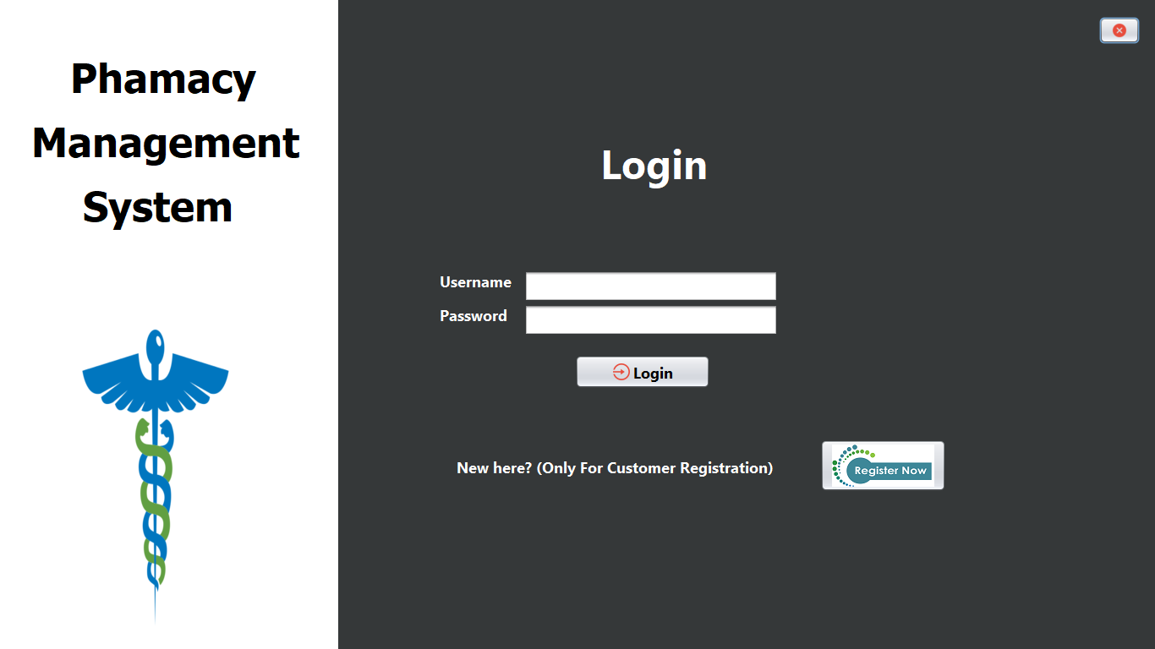

## **Register**

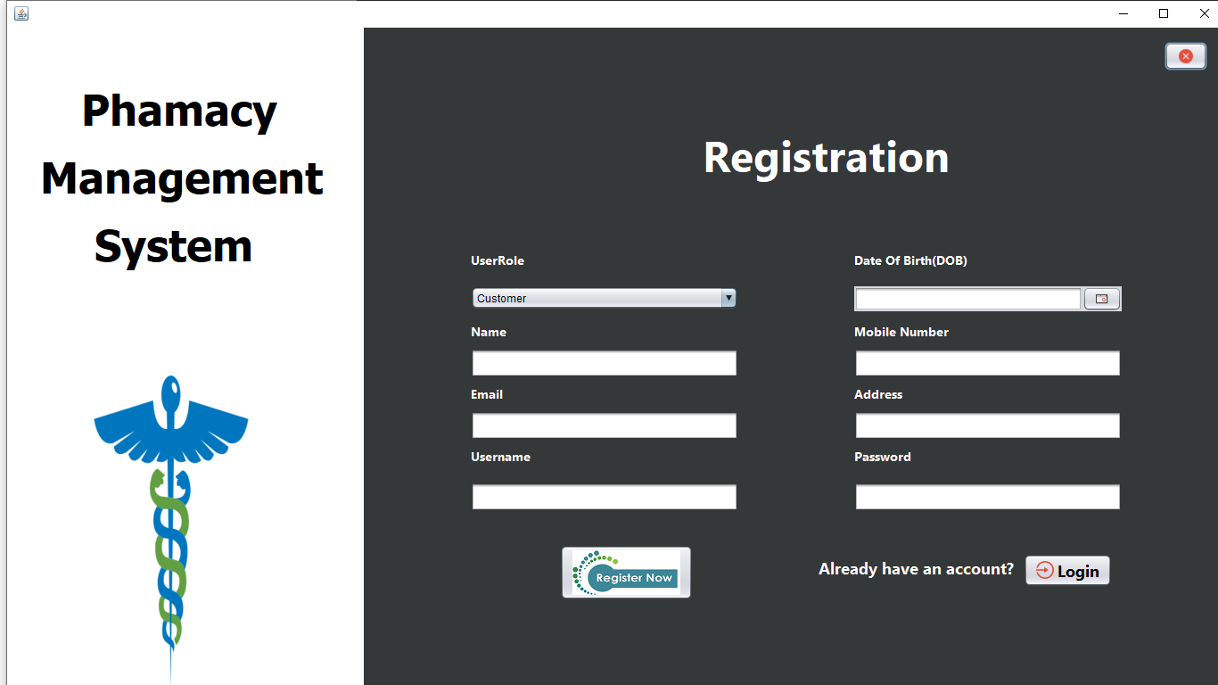

1. **AdminDashboard**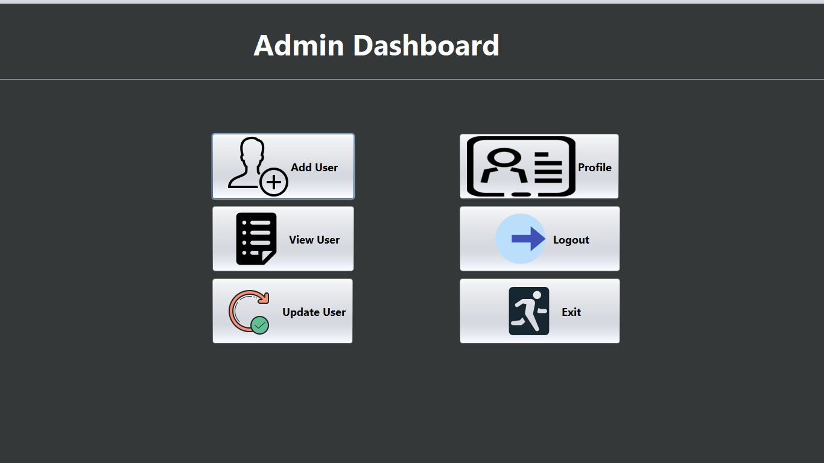

## **PharmacistDashboard**

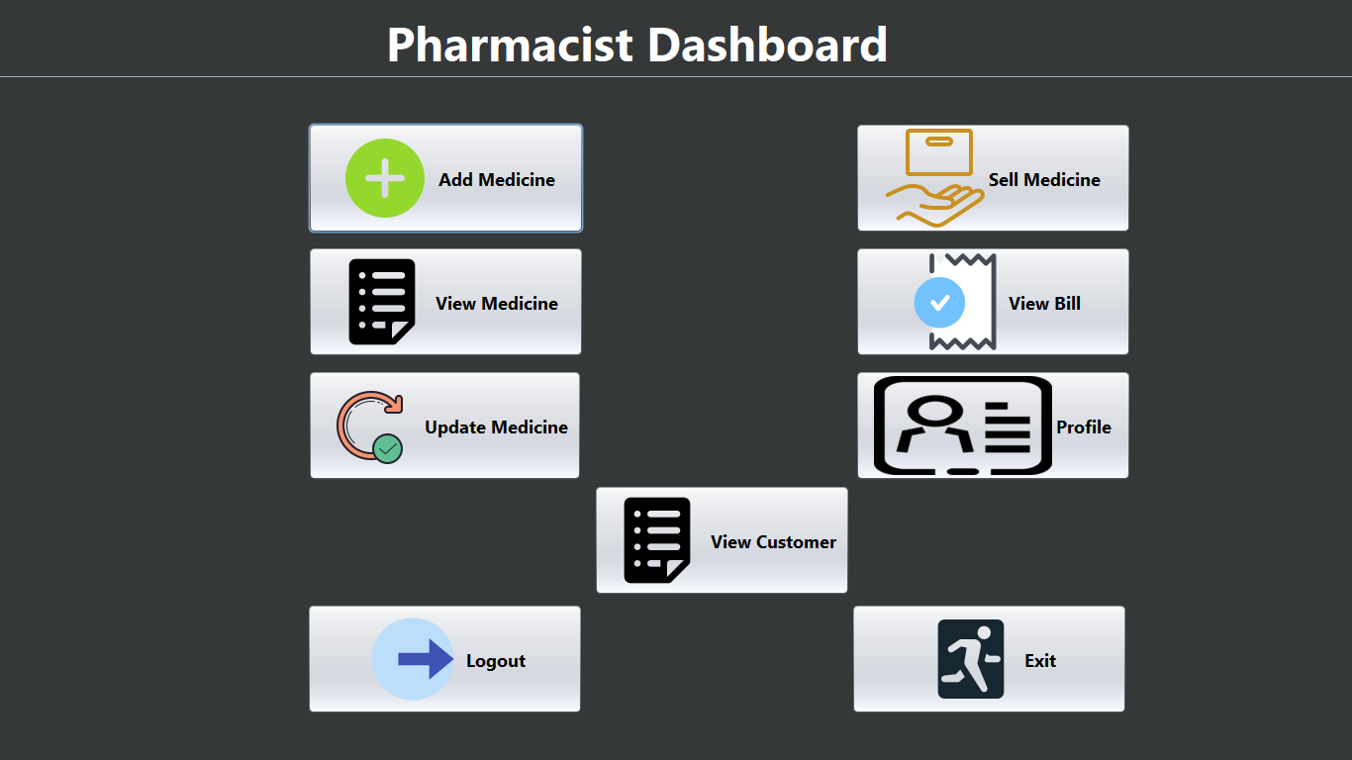

## **SellMedicine**

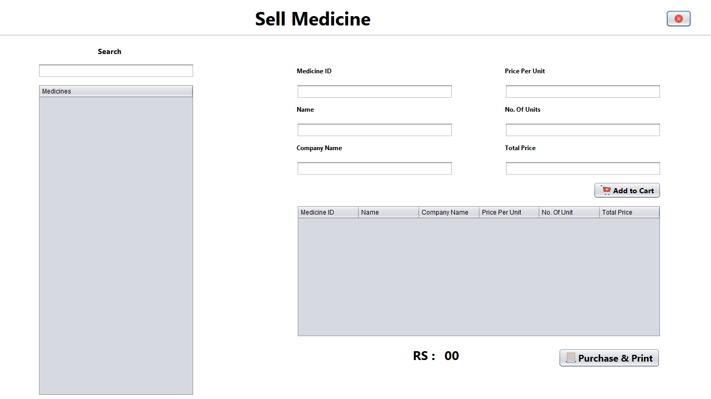

1. **Profile**

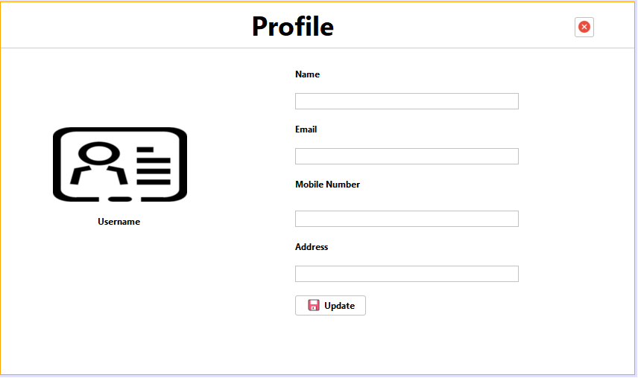

## **Add User**

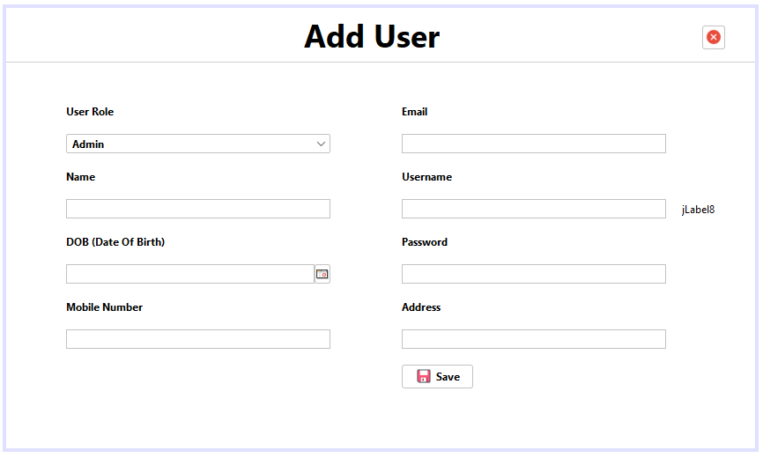

## **CustomerDashboard**

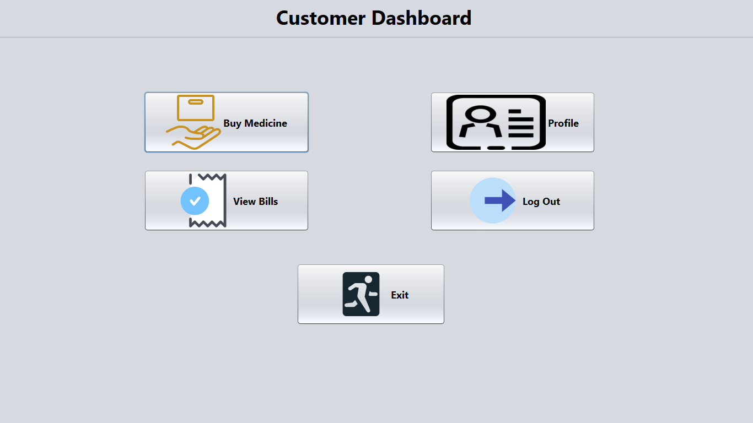

# 12. Final Ouput

The **Pharmacy Management System** is a Java-based desktop application developed to streamline and automate various operations in a pharmacy environment. The system provides a robust, user-friendly interface tailored for three distinct user roles—**Admin**, **Pharmacist**, and **Customer**—each with specific functionalities to ensure smooth and efficient workflows.

## **Key Features**

### ****1. Admin Module****

* Manages user accounts and system access.
* Adds, updates, and views user profiles.
* Oversees overall user management and system supervision.

### ****2. Pharmacist Module****

* Manages the medicine inventory (add, update, delete medicines).
* Handles medicine sales and billing operations.
* Generates sales invoices using PDF format.
* Maintains sales records for historical reference and auditing.

### ****3. Customer Module****

* Browses available medicines.
* Purchases medicines securely.
* Accesses transaction history for personal reference.

## **Technology Stack**

|  |  |
| --- | --- |
| **Component** | **Details** |
| **Programming Language** | Java SE (Standard Edition) |
| **Database** | MySQL |
| **GUI Framework** | Java Swing |
| **External Libraries** | - AbsoluteLayout (layout management)  - iText (PDF generation)  - JCalendar (date selection)  - MySQL Connector/J (database connectivity) |

## **System Benefits**

* **Automation** of routine pharmacy operations.
* **Reduction** of manual errors in sales and inventory management.
* **Improved efficiency** through streamlined user workflows.
* **Data integrity** and **security** with reliable database integration.
* **User-friendly interface** designed for clarity and ease of use.

# 13. Conclusion and Future Scope :

## **Conclusion**

The **Pharmacy Management System** successfully addresses the core needs of pharmacy operations by providing an efficient, automated platform that simplifies tasks for Admins, Pharmacists, and Customers. With features like inventory management, billing, user account management, and sales tracking, the system enhances productivity and reduces the potential for manual errors. Leveraging Java Swing for a responsive GUI and MySQL for secure data storage, the system ensures a smooth and reliable user experience.

By integrating libraries such as iText for PDF generation and JCalendar for date selection, the system offers practical functionality tailored to real-world requirements. Overall, this project demonstrates a solid foundation for digitizing pharmacy processes and improving operational transparency.

## **Future Scope**

While the current system meets the basic needs of a pharmacy, there is significant scope for future enhancements to increase its capabilities and reach:

### 🔹 ****Web and Mobile Integration****

* Develop a **web-based** or **mobile application** version to allow remote access and online medicine ordering.
* Enable **real-time synchronization** between desktop and online systems for broader accessibility.

### 🔹 ****Inventory Forecasting****

* Implement **AI or machine learning** algorithms to predict stock requirements based on historical sales data and seasonal trends.

### 🔹 ****E-Prescription Support****

* Integrate with healthcare providers to support **electronic prescriptions**, allowing customers to upload or receive prescriptions directly in the system.

### 🔹 ****Barcode and QR Code Integration****

* Use **barcode/QR scanning** for quick medicine lookup and billing, enhancing speed and accuracy in pharmacy operations.

### 🔹 ****SMS and Email Notifications****

* Send **automated alerts** to customers for medicine availability, expiry reminders, and promotional offers.

### 🔹 ****Multi-Store and Cloud Support****

* Expand to support **multi-branch pharmacies** with a centralized cloud-based database to manage all branches from a single platform.